Subscribe to the CTA newsletter to receive it directly via email. [Click here to find out more.](https://www.markethub.shell.com/content/nextgen/shell/us/en_us/ws/fuels/portal/home/shell-programs/shell-mobility-academy/cta-newsletter.html)

May 27, 2025

Featured Topics

**Fuel Rewards® New Member Offer Campaign: Barstool Sports**

We are excited to share that another new media tactic to promote the **Fuel Rewards® New Member Offer Campaign** will go live today, May 27th! Over the next month, the Fuel Rewards® New Member Offer will be featured in **Barstool Sports** on several of its platforms. Barstool Sports is a digital media company that focuses on sports content. It has a significant online presence and following, producing content across multiple platforms like web, social media, podcasts, video, and more.

To capitalize on the NHL playoffs, we will have a Fuel Rewards® audio ad read live by the hosts of Spittin’ Chiclets, a popular hockey podcast. We’ll also be featured in the “Ask Chiclets” segment that runs on their social media channels, including YouTube, Instagram, and TikTok. To reach an even broader audience, we’ll also be featured on the social media channels for Pardon My Take, another Barstool Sports podcast that focuses on sports news and analysis. Visit their social channels to see the podcast hosts promote the Fuel Rewards® New Member Offer!

Check out the Spittin’ Chiclets podcast script below and tune in wherever you get your favorite podcasts to hear it read live.

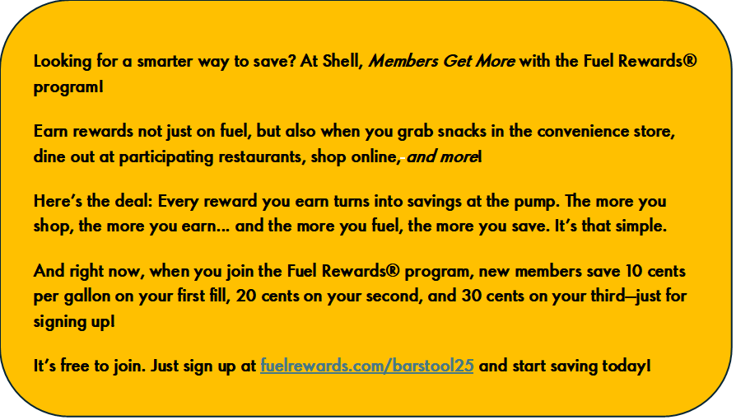

**NEW Shell Gift Card is Here!**

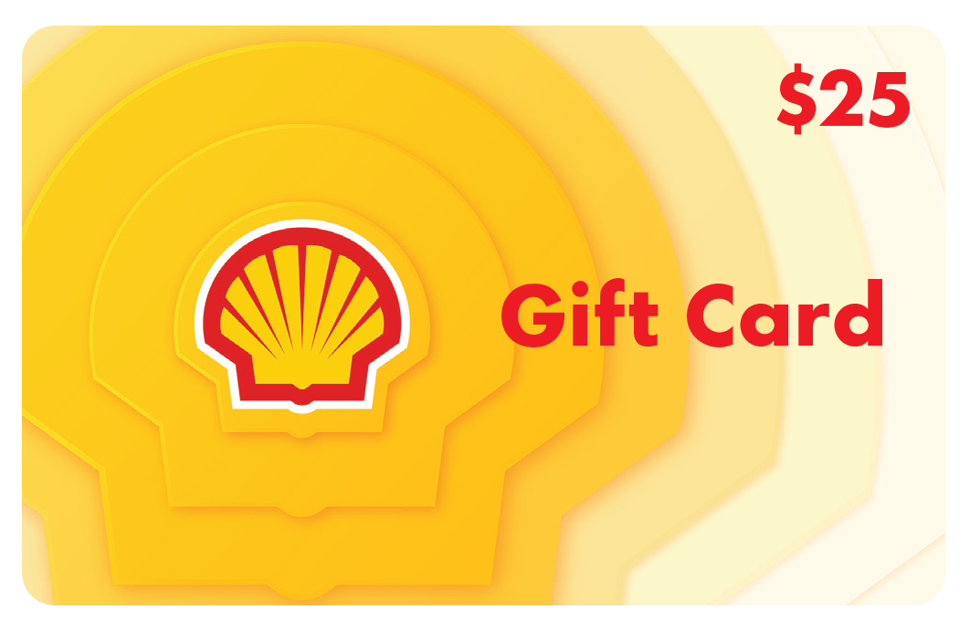We are excited to announce our newly redesigned Shell Gift Cards. This redesign re-energizes one of our longest-running branded payment products and further mitigates Gift Card fraud with added security features available. In addition, the new image drives consistency across sales channels to better resonate with consumers and stands out in busy gift card malls by putting the brand front and center. Fresh branding can also increase sales, meaning more consumers purchasing at Shell!

Card shipments will arrive at sites this week with detailed display instructions. Included in the instructions is information on how to remove and dispose of the previous gift card inventory and how to contact RPG for additional orders or questions related to the change.

As of **July 1st,** all the previous gift cards that were unsold will no longer be eligible for activation, so it’s very important that all sites help to replace the gift card inventory with the new shipment as soon as possible.

**What to Expect:**

* NO changes to how stores activate or redeem – new BIN range is already accepted in system
* All previous cards sold will continue to work as usual
* New cards can be added to the Shell App AND customers can now add MULTIPLE gift cards to their Shell eGift Card balance, up to $250!

To learn more and to view the flyer being sent to sites, please visit the [Gift Cards](https://www.markethub.shell.com/content/nextgen/shell/us/en_us/ws/fuels/portal/home/marketing/cards-payments/gift-cards.html) MarketHub page.

**Shell V-Power® NiTRO+ Brings MORE**

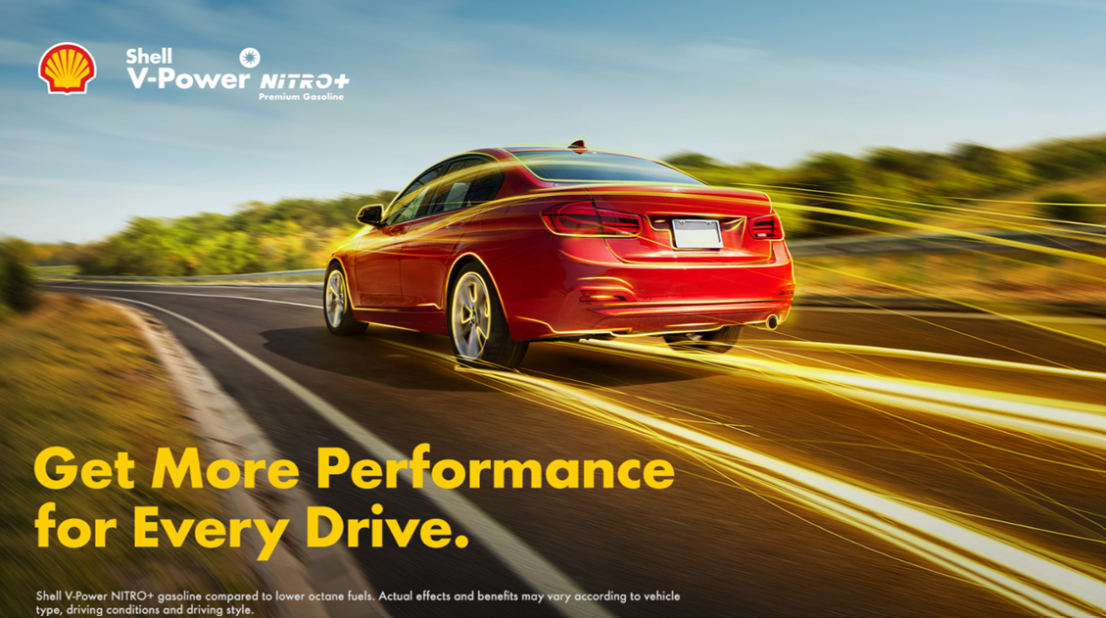The Fuels & Sponsorship Marketing team is excited to announce the official Shell V-Power® NiTRO+ (SVPN+) multi-channel campaign on May 27th. Building off of the success of last year’s campaign and continuing our collaboration with Loyalty, the new SVPN+ campaign will be highlighting “MORE”! We will be featuring all **new** campaign creative, giving customers MORE Performance, MORE Power and MORE Protection with fuel like no other. The campaign will be featured across various marketing channels such as Digital, Social, On-line TV and streaming audio. To get MORE details on the new creative, [click here](https://www.markethub.shell.com/content/nextgen/shell/us/en_us/ws/fuels/portal/home/marketing/advertising.html). You will also be able to download Digital, TVC (for Gas Station TV), Radio and Out of Home assets for amplification in your local markets. Stay tuned for Point of Purchase content which will be coming to you in early August.

***But wait…there’s MORE:***

Shell V-Power® NiTRO+ is also brining your customers MORE this Summer! SVPN+ is going to the movies!  There will be an exclusive SVPN+ commercial that will be showcased immediately before this Summer’s blockbuster F1 movie featuring Brad Pitt.[Click here](https://www.markethub.shell.com/content/nextgen/shell/us/en_us/ws/fuels/portal/home/marketing/fuel-products/gasoline/shell-v-power-nitro-plus.html) to see the official preview of the F1 movie. Customers who join Fuel Rewards® and existing Fuel Rewards® members have an opportunity to enter for the chance to win a VIP Experience at the Austin Grand Prix!  Winners will receive top-tier Grandstand seats, exclusive paddock tours, food, accommodation and Shell and Ferrari Merch!  This is yet another way SVPN+ continues to offer MORE.

There is still time for YOU to win MORE! The VIP Movie Experience wraps up at the end of May. The Wholesaler in each region with the greatest percentage increase in their daily Fuel Rewards® registrations between May 1st and May 31st win a VIP Movie Experience.

**VIP F1 Movie Experience Includes:**

* Exclusive Private Showing: Enjoy the F1 movie starring Brad Pitt.
* Private Theater Rental: A local movie theater reserved just for you, site staff and customers.
* **Food and Beverage:** Complimentary snacks and drinks for all attendees.
* Ferrari Merchandise
* **Winners Announced:** Week of June 9th

**Shell Ready - New Onboarding Program**

Shell Ready is Shell’s new onboarding platform and resource center for sites seeking to learn more about programs and guidance on program implementation. The first phase of Shell Ready is now available and is geared towards improving the ease of doing business with Shell. This new platform serves as a one-stop shop providing an organized approach to program adoption, just-in-time access to information and support, and clarity on the value of Shell programs from operational needs to customer loyalty.

Visit the [Shell Ready](https://eur02.safelinks.protection.outlook.com/?url=http%3A%2F%2Fclick.email.shell.us%2F%3Fqs%3Dbf3b5c660d5fc03fb1aacaeeb52124055d8e39a7fb0a58ee1b8d5c3bec4e813598ff2a10fd65717aa1b21e1373a5b268&data=05%7C02%7CAnna.Malygin%40shell.com%7Cb3db3b9c16814d3b7f4908dd996e415a%7Cdb1e96a8a3da442a930b235cac24cd5c%7C0%7C0%7C638835420991249924%7CUnknown%7CTWFpbGZsb3d8eyJFbXB0eU1hcGkiOnRydWUsIlYiOiIwLjAuMDAwMCIsIlAiOiJXaW4zMiIsIkFOIjoiTWFpbCIsIldUIjoyfQ%3D%3D%7C0%7C%7C%7C&sdata=ZSoLrdccr4u%2BO0SvfOweBsAMKnPchalkPJNPLj0Y3vc%3D&reserved=0) page on MarketHub and get familiar with the variety of Shell programs and various features available to Wholesalers. Be sure to invite your new and existing retailers to access the Shell Ready platform.



**June Session:** Meet the Shell Corporate Relations Team

[Click here](https://www.markethub.shell.com/content/nextgen/shell/us/en_us/ws/fuels/portal/home/shell-programs/shell-mobility-academy/shell-mobility-academy-webinars.html) to join us June 3 at 11 AM CST for the Shell Mobility Academy Webinar.

Join us for a special session where you can meet your Shell Regional Representatives from our Corporate Relations Team. This Team represents Shell before Governors, legislatures and state and local Governments throughout the US. They also work with Trade associations to monitor relevant bills and advocate for or against them as necessary.

During this session, hear from this team about how Shell is representing policies on both a Federal and regional level in your geography.

The US Corporate Relations team is divided into four regions. For this special TEAMS call, you’ll have the opportunity to join a breakout room that pertains to the geography.

The Power of Loyalty

In-Store Rewards – June Offers

Help drive consumer awareness and increase your c-store sales by printing the POP and displaying the In-Store Rewards products near the register. As a reminder, members with Platinum Status earn 2x on all In-Store Rewards offers.

* **Power Deal – Buy 3 100% Natural Spring Water 700ml, earn 10¢/gal**
* Buy 1 Sparkling Ice Caffeine 12-16oz, earn 3¢/gal
* Buy 2 Hershey's Family King Size, earn 5¢/gal
* Buy 1 100% Natural Spring Water Aluminum Bottle 25oz, earn 5¢/gal
* Buy 1 Pure Life Case Pack 24/16.9oz., earn 5¢/gal
* Buy 1 Pure Life Aluminum 20oz., earn 5¢/gal
* Buy 2 Large Jolly Rancher, Twizzlers, or SHAQ-A-LICIOUS 5.3-7oz, earn 5¢/gal
* Buy 1 Snapple® any size, earn 5¢/gal
* Buy 2 Tic Tac 1.7 oz packs, earn 5¢/gal

[Click here](https://www.markethub.shell.com/content/nextgen/shell/us/en_us/ws/fuels/portal/home/marketing/loyalty/in-store-rewards.html) to view the reference materials including high resolution artwork, POP templates for local printing, flyer with UPCs, change mat inserts and Wayne Anthem dispenser slides. Check the Fuel Rewards® or Shell App regularly to view additional short-term digital only offers.

If you have any questions, please contact[mark.dyer@shell.com](mailto:mark.dyer@shell.com).

Shell Program Updates

**PMTDR**

**Smiling Stars Toronto Countdown!**

For the 2024 top 1% winners, the Smiling Stars Toronto trip is almost here! Instructions on how to download the Smiling Stars event app will be sent to attendees by May 27th. Please download the app as it will be the source of information and communication throughout the week. For more information, reach out to [Kathie.Corner@shell.com](mailto:Kathie.Corner@shell.com).

**Smiling Stars Americas Region Heroes!**

Congratulations to our US heroes who will be recognized on the Smiling Stars Toronto trip!  These winners were nominated by their wholesalers and selected by a Shell Leadership panel to represent the Americas Region.  All these winners are in the running for Global recognition!  Good luck and congratulations to:

* **Frontline Hero: Candace McCarty, Colbea**
* **Fuels Hero: Ismar Gramajo, Conico**
* **EV Hero: Juan Rivera, Crawford Oil**

**Wholesalers:** The 2025 window to nominate your heroes will open in the Fall. More information to come.

**PMTDR Annual Program Fee Billing Final Reminder**

The 2025 PMTDR annual program fee is $425 per site and will be billed at the end of May/beginning of June.  The program fee is eligible for 50% co-op reimbursement.  If you wish to make any changes to your enrolled sites prior to the annual billing, please contact your Territory Manager or [Kathie.Corner@shell.com](mailto:Kathie.Corner@shell.com) for assistance.

**YMTDR**

* **YMTDR trip highlights:** The YMTDR wholesaler recognition trip took place in Cannes, France. For a few of the highlights, [click here!](https://www.markethub.shell.com/content/nextgen/shell/us/en_us/ws/fuels/portal/home/shell-programs/wholesaler-programs/ymtdr.html)
* **Destination announcement:** We’re excited to announce the 2026 YMTDR wholesaler trip destination! [Click here](https://www.markethub.shell.com/content/nextgen/shell/us/en_us/ws/fuels/portal/home/shell-programs/wholesaler-programs/ymtdr.html) for the details
* **Reward Program Period 1 Ranking:** The MMP Period 1 appeals/cure window closes mid-May.  PMTDR and YMTDR rank will take place as soon as final scores are available.

New In-App Offer: Winning Wednesdays with Joey Logano

When Joey wins, Fuel Rewards® members win even more! Starting in May, Fuel Rewards® members can use their Shell App to opt-in to redeem 22¢/gal the Wednesday after Joey Logano wins a race on Sunday in No. 22 Shell-Pennzoil team car.

How it works:

1. Joey Logano wins a race on Sunday in the No. 22 Shell-Pennzoil team car.
2. Fuel Rewards® members can go into the Shell App on the following Monday --Wednesday and opt-in to receive their 22¢/gal when they fill.
3. Members who have opted in can redeem their 22¢/gal at any participating Shell station any time Wednesday that week*.

*Terms apply, offer ends November 5, 2025