Subscribe to the CTA newsletter to receive it directly via email. [Click here to find out more.](https://www.markethub.shell.com/content/nextgen/shell/us/en_us/ws/fuels/portal/home/shell-programs/shell-mobility-academy/cta-newsletter.html)

March 25, 2025

Featured Topics



**The Giving Pump 2025: Enrollment is Open!**

Join us for another impactful year of The Giving Pump! In 2025, our marketing campaign will highlight the stories of impact – featuring wholesalers and the charities they support. We’re also thrilled to be working with St. Jude’s Children’s Research Hospital as our turnkey charity partner this year! Enrollment for The Giving Pump is open until May 9. To access the enrollment portal and get more information about The Giving Pump 2025, please visit the [Force for Good MarketHub Page](https://www.markethub.shell.com/content/nextgen/shell/us/en_us/ws/fuels/portal/home/shell-programs/force-for-good.html).

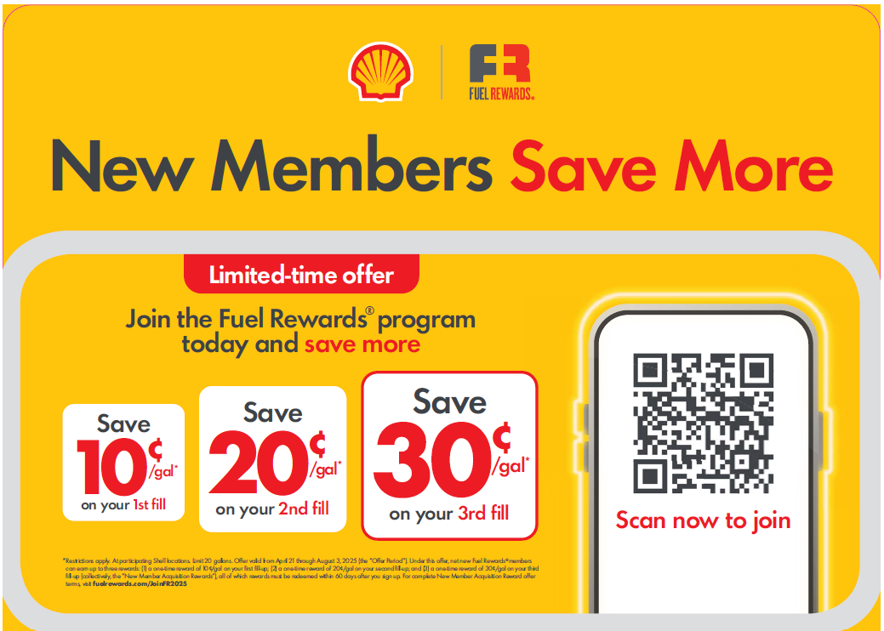**Fuel Rewards® New Member Offer Campaign**

The Fuel Rewards® New Member Offer Campaign is quickly approaching! Launching on April 21, New Fuel Rewards® members that join the program by August 3 will earn 10¢/gal on their first fill, 20¢/gal on their second fill, and 30¢/gal on their third fill. This campaign is focused on getting more members to sign up for the Fuel Rewards® program by highlighting how Members Get More!

As a reminder, there will be exciting contests and activation elements that wholesalers and sites can take advantage of:

* **\*ONE WEEK LEFT\*** Cashier T-Shirts: Promotional T-shirts have been created for site staff to wear and engage with customers during this campaign. Ordering is open until March 31 through ANC.
* **\*COMING SOON\*** New Training Videos: Starting in April, there will be new educational training videos aimed to be simple yet impactful for site staff about the Fuel Rewards® program and the New Member Offer.
* **Site Staff Rewards – Race to Win Contests:** Site Staff will have the opportunity to win all expense paid trips to NASCAR Races, signed Joey Logano Merch, and gift cards!
* **Aligned New Member Offer:** The new 10-20-30 cpg offer is available for customers wherever customers sign up, including Site Staff Rewards!

To best activate at sites, site staff should:

* Enroll in the Site Staff Rewards Program at [SiteStaffRewards.com](https://sitestaffrewards.com/)
* Complete new site staff training once available in April
* Post the POP materials on Monday, April 21 (Kits will arrive by April 17)
* Review the Site Staff Training Guide and Cashier Script within the POP Kit

Digital copies of the Planogram, Cashier Script, and Site Staff Training Guides are now available on the [Advertising MarketHub Page](https://www.markethub.shell.com/content/nextgen/shell/us/en_us/ws/fuels/portal/home/marketing/advertising.html).

To learn more about the Fuel Rewards® New Member Offer Campaign, including t-Shirt ordering information and the Site Staff Rewards contest details, visit the [Fuel Rewards® MarketHub Page](https://www.markethub.shell.com/content/nextgen/shell/us/en_us/ws/fuels/portal/home/marketing/loyalty/fuel-rewards.html).

**Network Transformations - MORE from EDGEPro is coming soon!**

We are excited to announce that we have achieved over 8,500 successful installations for EDGEPro boxes across the Shell network. Thank you all for your diligence in moving towards EDGEPro completion as we will soon be announcing the exciting features EDGEPro delivers. As the Diebold/Vantage device reaches end-of-life, we look forward to the future of cloud driven technology to best support you.

**EDGEPro Reminders and Actions:**

* Complete your EDGEPro Installation by **May 31, 2025** to be reimbursed for the EDGEPro box. The site must be CORE compliant and have EDGEPro installed to receive reimbursement (typically within 30 days of installation).
  + Those that complete EDGEPro Installation across your network by **March 31, 2025** will receive one free spare EDGEPro Box (for every 100 sites.)
* **Installation Support**
  + Managed Install, an option where Shell and Invenco manage the ordering/scheduling/installation of the EDGEPro box, is a great option to ensure your sites are compliant by May 31, 2025. Ask your Deployment Coordinator to set this up for you!
  + [Schedule a call with a Deployment Coordinator](https://mymail.shell.com/book/NetworkTransformations@ShellCorp.onmicrosoft.com/)
  + [View your Network Transformations Report](https://www.markethub.shell.com/content/nextgen/shell/us/en_us/ws/fuels/portal/home/supply-reports/performanceworkspace.html) (compliance statuses are included)

**MORE from EDGEPro with Shell** coming soon!

Action: Join the Shell Mobility Webcast on April 8th to learn more about when and how to activate these new capabilities at your Shell locations.

**Action:** [**Designate an Operations Enhancement focal.**](https://www.markethub.shell.com/apps/utils/thirdparty.rdm?target=95) **This person will begin receiving Network Transformations specific updates in April 2025.**



**April Session:** Network Transformations

[Click here](https://www.markethub.shell.com/content/nextgen/shell/us/en_us/ws/fuels/portal/home/shell-programs/shell-mobility-academy/shell-mobility-academy-webinars.html) to join us April 8 at 11 AM CST for the Shell Mobility Academy Webinar.

During this session, we will walk through how to prepare your sites for the New Payment Platform, Shell MarketHub 2.0 transition and dive into exciting updates regarding MORE from EDGEPro with Shell!

To maximize the benefit of this session for your organization we ask that your Principal, Operational Enhancements focal point and your EDGEPro lead attend this call. We are excited for all that 2025 will bring to the Shell network! To learn more about Shell Mobility sessions and to view previous session recordings, visit the Mobility Academy MarketHub page

The Power of Loyalty

**Fuel Rewards® Platinum Status**

April Offers and Experiences

In addition to saving at least 10¢/gal and earning 2x on In-Store Rewards, a special benefit for Fuel Rewards® members with Platinum Status is access to special VIP offers and experiences. In April, there are three great offers.

* + **Roomba® Sweepstakes**
    - 125 winners
    - Sweepstakes ends April 18

* + **$25 Amazon eGift Card Sweepstakes**
    - 1,000 winners
    - Sweepstakes ends April 18



**Earn an Extra 25¢/gal Through Online Shopping**

In April, all Platinum Status members can earn a one-time extra 25¢/gal reward when they spend $50 on qualifying purchases through the Fuel Rewards® program’s online mall.

In-Store Rewards – April Offers

Help drive consumer awareness and increase your c-store sales by printing the POP and displaying the In-Store Rewards products near the register. As a reminder, members with Platinum Status earn 2x on all In-Store Rewards offers.

* **Power Deal – Buy 2 Celsius, earn 7¢/gal**
* Buy any 3 100% Natural Spring Waters (20 oz), earn 7¢/gal
* Buy any 1 100% Natural Spring Waters (25 oz Aluminum Bottle), earn 5¢/gal
* Buy 2 Trident Singles, earn 5¢/gal
* Buy 1 Saratoga 16oz/28oz, earn 5¢/gal
* Buy 3 Sparkling Ice Caffeine (16 oz), earn 5¢/gal
* Buy 1 Pure Life Aluminum 20oz., earn 5¢/Gal

View the reference materials, including high-resolution artwork, and more information on the [In-Store Rewards MarketHub Page](https://www.markethub.shell.com/content/nextgen/shell/us/en_us/ws/fuels/portal/home/marketing/loyalty/in-store-rewards.html). Check the Fuel Rewards® or Shell App regularly to view additional short-term digital only offers. For any questions, contact [Mark.Dyer@shell.com](mailto:Mark.Dyer@shell.com).

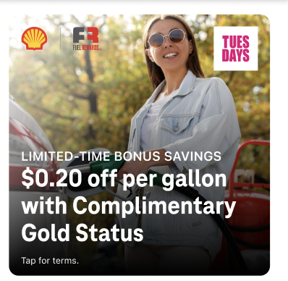**T-Mobile Tuesday Customers Can Earn More**

Starting March 18 through April 8, T-Mobile Tuesday customers can earn up to 20¢/gal every week! This offer is inclusive of Gold Status and is limited to 20 gallons per fill. T-Mobile customers can earn this additional savings by going into the T-life app every Tuesday during the offer period, redeeming their unique code for 15¢/gal additional savings, and inserting their code into their Fuel Rewards® account.

**Exclusive Fuel Rewards® Savings for AARP Members**

Starting on March 10, AARP members can now save 50¢/gal on their 1st fill-up when they join the Fuel Rewards® program and link their AARP account. The offer is available to current or new AARP members that join the Fuel Rewards® program using the custom link ([Join and Link Accounts](https://secure.aarp.org/applications/user/vendor/acctConfirm?request_locale=en&vn=shellpdi)). The one-time 50¢/gal offer includes Gold Status and is limited to 20 gallons. AARP members will continue to save at least 5¢/gal with Complimentary Gold Status.

**Fuel Rewards® Point-of-Sale Enrollment Decals and Lug-Ons**

|  |  |
| --- | --- |
| **SKU** | **Item** |
| EQV14664 | FRE Decal NCA 9.25 x 1.125 |
| EQV14665 | FRE Pin Pad Lug On 2022 |
| EQV14887 | Grocer - Generic Installation POG |

Fuel Rewards® Point of Sale Enrollment (FRE) was launched in 2018 as an easy, fast, and low touch way to grow more loyal customers at your sites! If a customer is prompted, they can instantly save 5¢/gal when they enter their mobile number and will receive a text message to sign up for the Fuel Rewards® program. Since FRE was launched, it has been that largest channel for acquiring new members. Please ensure all sites that have FRE enabled are displaying the required dispenser decal and PIN pad lug-on. Replacements can be ordered on the Beyond POP page by typing FRE or the SKU in the search box.

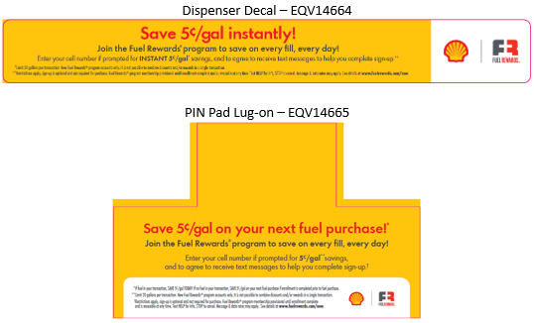

Shell Program Updates

**Shell + XPEL: A New Partnership to Protect Your Pumps**

Data from the 2024 Shell Mystery Motorist Program continues to cite Pump Maintenance as the #1 missed Site Essential across the network. Along with damaged decals and product labels, damaged equipment and graffiti round out the top infractions for pump compliance. Furthermore, research shows that 45% of consumers would not return to a Shell station due to pump-related issues.

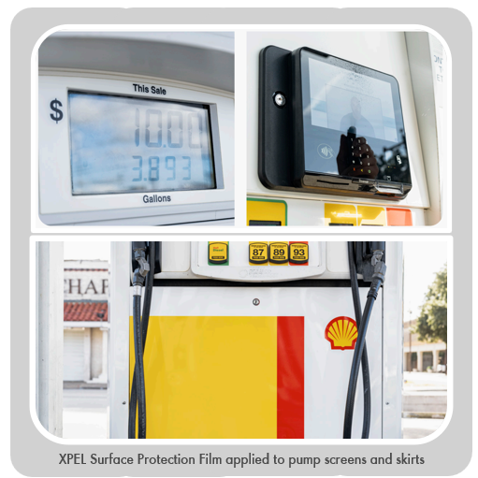To address Pump Maintenance, Shell collaborated with [XPEL](https://www.xpel.com/), the global leader in surface protection Films, to create a solution that helps prevent and reduce pump wear and tear. XPEL’s innovative film provides superior protection and features self-healing technology to repair minor scratches and lines on pump surfaces, including display screens, pump skirts and riser panels.

Following 12 months of successful testing at Shell locations, we are excited to announce a **NEW, exclusive** **XPEL Diamond Deal eligible for 100% co-op reimbursement**. XPEL’s turnkey program includes a custom quote based on your location’s needs plus professional installation of XPEL’s film backed by a 10-year transferable warranty.

Go directly to the [XPEL | Shell webpage](https://lp.xpel.com/motiva-shell) or visit the [Diamond Deal Vendors page](https://www.markethub.shell.com/content/nextgen/shell/us/en_us/ws/fuels/portal/home/site-operations/vendors/diamond-deals.html) in MarketHub for XPEL program details, pricing, and to inquire about receiving a custom quote from a XPEL representative.

If you have additional questions about the XPEL Diamond Deal, contact [Meg Love.](mailto:Meg.Love@shell.com)

**PMTDR: Upcoming Nashville trip, Billing, and Scorecard Information**

**Nashville Countdown!**

We’re excited to welcome the top 5% of sites to Nashville to celebrate their 2024 success! Look for highlights and photos in the CTAs to come!

**PMTDR Annual Program Fee Billing**

The 2025 PMTDR annual program fee is $425 per site and will be billed at the end of May/beginning of June. The program fee is eligible for 50% co-op reimbursement. If you wish to make any changes to your enrolled sites prior to the annual billing, please contact your Territory Manager or [Kathie.Corner@shell.com](mailto:Kathie.Corner@shell.com) for assistance.

**PMTDR 2025 Scorecard & P1 Rank**

[**Click here**](https://eur02.safelinks.protection.outlook.com/?url=https%3A%2F%2Fwww.markethub.shell.com%2Fcontent%2Fnextgen%2Fshell%2Fus%2Fen_us%2Fws%2Ffuels%2Fportal%2Fhome%2Fshell-programs%2Fwholesaler-programs%2Fpmtdr.html&data=05%7C02%7CAnna.Malygin%40shell.com%7Cc0e581737d4240b55a0f08dd65689508%7Cdb1e96a8a3da442a930b235cac24cd5c%7C0%7C0%7C638778222018391279%7CUnknown%7CTWFpbGZsb3d8eyJFbXB0eU1hcGkiOnRydWUsIlYiOiIwLjAuMDAwMCIsIlAiOiJXaW4zMiIsIkFOIjoiTWFpbCIsIldUIjoyfQ%3D%3D%7C0%7C%7C%7C&sdata=CUzTD8%2BcILYOojHXFAiD3wTHaWjgcNtmFj5BqOksyDY%3D&reserved=0) for the 2025 PMTDR Scorecard. The first period top 10% rank will be completed upon the close of the MMP appeals window. Wholesalers with sites ranked within the top 10% of the region will receive six Visa Gift cards of $25 or $150 per site to present to their winning teams

**PMTDR 2026 Scorecard | 2027 Trips**

To give wholesalers more time to identify trip winners and announce winners at January kick-off meetings, the 2026 PMTDR scorecard will use data October 2025-October 2026 for KPI calculations allowing for delivery of rank information in December 2026 for the 2027 trips.

* **MMP Shop P3 2025, P1 2026, P2 2026**
* **Fuel Volume October 2025 – October 2026 (rolling 12 months)**
* **Loyalty Volume October 2025 – October 2026 (rolling 12 months)**