Subscribe to the CTA newsletter to receive it directly via email. [Click here to find out more.](https://www.markethub.shell.com/content/nextgen/shell/us/en_us/ws/fuels/portal/home/shell-programs/shell-mobility-academy/cta-newsletter.html)

January 28, 2025



**February Session:**

**2025 Marketing Calendar and Media Strategy**

[Click here](https://www.markethub.shell.com/content/nextgen/shell/us/en_us/ws/fuels/portal/home/shell-programs/shell-mobility-academy/shell-mobility-academy-webinars.html) to join us on February 11 at 11 AM CST for the Shell Mobility Academy Webinar.

This session will cover the full year calendar, highlighting when all marketing campaigns will run as well as which channels they will show up in. Additionally, it will cover the 2025 media strategy and how Shell is using data and technology in its marketing plans to further connect with consumers.

The Power of Loyalty

**New Fuel Rewards® Collaboration with Ford and Lincoln**

Beginning January 13, FordPass Silver & Blue Tier members and Lincoln Access members are now able to save at participating Shell stations with Fuel Rewards®! All members will earn at least 5¢/gal with Complimentary Gold status. New Fuel Rewards® members, who sign up through FordPass or Lincoln Access, will save up to 25¢/gal on their first fill. We are excited to launch this new collaboration and bring more ways to save to our members!

**New Fuel Rewards® Collaboration with Stellantis**

Launching on February 3, Fuel Rewards® and Shell will be welcoming the Stellantis brand family (Chrysler, Dodge, Jeep, Ram, Fiat® and Alfa) to the program. For the first 3 months, new Fuel Rewards® members that join through the Stellantis vehicle branded app powered by Uconnect®, will earn 25¢/gal on their first fill at participating Shell Stations. These new members will continue to receive a limited time offer of 8¢/gal on their first 5 fills each month. The offer includes Gold Status and is limited to 20 gallons.

**Fuel Rewards® Platinum Status – February Offers and Experiences**

In addition to saving at least 10¢/gal and earning 2x on In-Store Rewards, a special benefit for Fuel Rewards® members with Platinum Status is access to special VIP offers and experiences. For February, there are two great offers.

**New Orleans Jazz & Heritage Festival**

Fuel Rewards members with Platinum Status can enter a sweepstakes for a chance to win a trip for them and 1 guest to New Orleans. The 3 winners and their guest will enjoy the sounds of Jazz Fest and the legendary food of New Orleans.

* + 3 winners + 1 guest each
  + Four 2-day tickets to New Orleans Jazz & Heritage Festival
  + Access to Shell’s hospitality lounge at Jazz Fest
  + Flights and accommodations for 3 nights
  + Dinner at a 5-star restaurant
  + One tour of choice selected by winner
  + e.g. food & cocktail, ghost, or historic tour
  + $500 Visa gift card
  + Sweepstakes ends February 16



**Special Dining Offer**

This February, members with Platinum Status earn a one-time bonus 50¢/gal reward from their first $50 spent with a linked payment card at participating restaurants. That’s in addition to the typical 10¢/gal Fuel Rewards members earn from dining and their everyday Platinum Status. That is 70¢/gal in savings.

**In-Store Rewards – February Offers**

Help drive consumer awareness and increase your c-store sales by printing the POP and displaying the In-Store Rewards products near the register. As a reminder, members with Platinum Status earn 2x on all In-Store Rewards offers. That’s 20¢/gal on Power Deals.

* **Power Deal – Buy any 3 Big Bag (Oreo, Chips Ahoy, Ritz, and Nutter Butter) or belVita, earn 10¢/gal**
* Buy any 2 100% Natural Spring Waters (1 L) & 1 Saratoga (16 oz), earn 10¢/gal
* Buy any 2 100% Natural Spring Waters (20 oz), earn 5¢/gal
* Buy 2 Pure Life 1L, earn 5¢/gal
* Buy 2 Sparkling Ice Caffeine (16 oz), earn 5¢/gal
* Buy 2 Pure Life 1L, earn 5¢/gal
* Buy 2 Red Vines, earn 5¢/gal
* Buy 1 Rice Krispies Treats Dunk'd Bars, earn 5¢/gal
* Buy 1 Pillsbury Mini Soft Baked Cookies, earn 4¢/gal

[Click here](https://www.markethub.shell.com/content/nextgen/shell/us/en_us/ws/fuels/portal/home/marketing/loyalty/in-store-rewards.html) to view the reference materials including high resolution artwork, POP templates for local printing, flyer with UPCs, change mat inserts and Wayne Anthem dispenser slides. Check the Fuel Rewards® or Shell App regularly to view additional short-term digital only offers.

If you have any questions, please contact[mark.dyer@shell.com](mailto:mark.dyer@shell.com)

**Enhanced Fuel Rewards® Offer for New AAA Members**

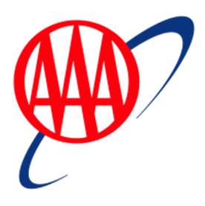New AAA members who link a Fuel Rewards® account can earn $1 off per gallon on their first 3 fills! The new AAA members can either join the Fuel Rewards® program or be an existing Fuel Rewards® to earn the savings, once they link their accounts. The first fill must be completed within 30 days of earning the reward. The introductory offer is inclusive of Gold Status. This limited-time offer will run from January 29, 2025 – December 31, 2025. The offer is limited to 20 gallons per fill. After the first three fills are completed, members can enjoy ongoing complimentary Gold Status with their AAA membership.

**Q1 Marketing Plans and Media Strategy**

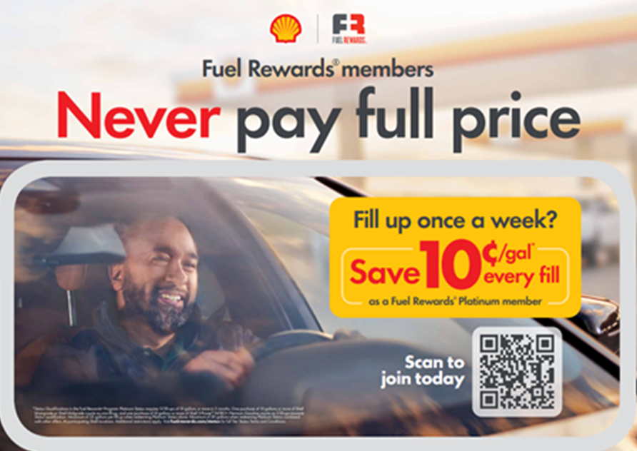Shell is kicking off the year with exciting marketing efforts in the first quarter! Our current national marketing campaign is focused on growing the number of our most valuable customers – Fuel Rewards® members with Platinum Status. For this campaign, we’ve simplified our messaging to communicate that filling up just 1x per week can earn Platinum Status, allowing members to save 10CPG on every fill. This encourages more frequent visits and fosters new consumer habits. We are also marketing Shell V-Power® NiTRO+, Sports Sponsorships and more in Q1.   
   
For these current campaigns, as well as the remainder of our campaigns this year, we are leveraging data, technology, and a multi-channel approach to reach consumers differently and more effectively.  
   
To learn more about our Q1 marketing and channels, as well as the tools Shell uses for campaign channel selection, view the [Shell Q1 Marketing Overview Pack](https://eur02.safelinks.protection.outlook.com/?url=http%3A%2F%2Fclick.email.shell.us%2F%3Fqs%3D0d9c66475548cad4455307606eac3bf7254b96d913fe889392879afce6aa43a30bb78b97901ffb07f3797bbe074fee4c&data=05%7C02%7Canna.malygin%40shell.com%7C9c83a021a80247c8a3f908dd3646eade%7Cdb1e96a8a3da442a930b235cac24cd5c%7C0%7C0%7C638726400405348142%7CUnknown%7CTWFpbGZsb3d8eyJFbXB0eU1hcGkiOnRydWUsIlYiOiIwLjAuMDAwMCIsIlAiOiJXaW4zMiIsIkFOIjoiTWFpbCIsIldUIjoyfQ%3D%3D%7C0%7C%7C%7C&sdata=1P4gEMK3w15ywEMjEkmuUqMd3oDMblzS2sztSf9%2B6X0%3D&reserved=0). Please also join us on **February 11 for the Shell Mobility Academy Webinar** where we will dive into the information and share more on the 2025 approach.

**Shell Mobility LinkedIn Page Now Live!**

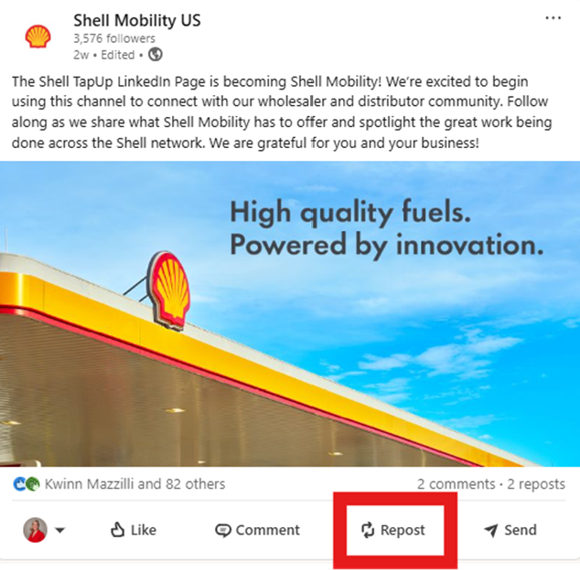We're thrilled to announce the launch of our new [Shell Mobility US LinkedIn Page](https://eur02.safelinks.protection.outlook.com/?url=https%3A%2F%2Flinkedin.com%2Fcompany%2Fshell-mobility&data=05%7C02%7CAnna.Malygin%40shell.com%7C4f6a1d2423974552cfbd08dd3b074b66%7Cdb1e96a8a3da442a930b235cac24cd5c%7C0%7C0%7C638731624683768283%7CUnknown%7CTWFpbGZsb3d8eyJFbXB0eU1hcGkiOnRydWUsIlYiOiIwLjAuMDAwMCIsIlAiOiJXaW4zMiIsIkFOIjoiTWFpbCIsIldUIjoyfQ%3D%3D%7C0%7C%7C%7C&sdata=Q7ksrnxiqxfrsjHLj7hlu2VaamkvAXsfNzKe5AhuFUA%3D&reserved=0), designed specifically for our valued wholesalers and dealers. This dedicated social channel will feature exciting content about our brand, activations, and the overall industry and is tailored just for the wholesaler and dealer audience.  
  
**Content to be covered:**

* Race Days at Shell Sponsored Events (e.g., Daytona 500, Pennzoil 400)
* New Site Spotlights
* Tradeshow Highlights
* Industry Updates

**Directions should you wish to share:**

* Login to LinkedIn
* Navigate to the [Shell Mobility LinkedIn Page](https://eur02.safelinks.protection.outlook.com/?url=https%3A%2F%2Flinkedin.com%2Fcompany%2Fshell-mobility&data=05%7C02%7CAnna.Malygin%40shell.com%7C4f6a1d2423974552cfbd08dd3b074b66%7Cdb1e96a8a3da442a930b235cac24cd5c%7C0%7C0%7C638731624683788192%7CUnknown%7CTWFpbGZsb3d8eyJFbXB0eU1hcGkiOnRydWUsIlYiOiIwLjAuMDAwMCIsIlAiOiJXaW4zMiIsIkFOIjoiTWFpbCIsIldUIjoyfQ%3D%3D%7C0%7C%7C%7C&sdata=YmVKGbQFTiLJjSDIBp8gAs1QjmuCvVBtcYTZ9P5v70U%3D&reserved=0)
* Scroll to bottom of a post and click Repost
* Instantly repost or add your thoughts

If you would like to stay updated, engage with our posts, and share your thoughts, [follow us on LinkedIn](https://eur02.safelinks.protection.outlook.com/?url=https%3A%2F%2Flinkedin.com%2Fcompany%2Fshell-mobility&data=05%7C02%7CAnna.Malygin%40shell.com%7C4f6a1d2423974552cfbd08dd3b074b66%7Cdb1e96a8a3da442a930b235cac24cd5c%7C0%7C0%7C638731624683788192%7CUnknown%7CTWFpbGZsb3d8eyJFbXB0eU1hcGkiOnRydWUsIlYiOiIwLjAuMDAwMCIsIlAiOiJXaW4zMiIsIkFOIjoiTWFpbCIsIldUIjoyfQ%3D%3D%7C0%7C%7C%7C&sdata=YmVKGbQFTiLJjSDIBp8gAs1QjmuCvVBtcYTZ9P5v70U%3D&reserved=0)!

Shell Technology Updates

**EDGEPro Mass Deployment News**

As announced in the December Shell Mobility Academy, January kicks off EDGEPro Mass Deployment! The EDGEPro Mass Deployment signifies our confidence in the stability, scalability, and supportability of the solution. Currently, over 6000 sites have installed EDGEPro, with the vast majority reporting a simple installation process of less than one hour. In this article, you will find important information related to the EDGEPro Mass Deployment, including important reminders, exciting incentives, deployment support, and wholesaler actions.

**Important Reminders**

**The new deadline to complete your network installation is May 31, 2025**. As a reminder, you must complete the EDGEPro installation before May 31 to be reimbursed for the cost of the device. The current Wincor device has reached end-of-life and will no longer be supported. The EDGEPro device is the foundation for future innovative features.

The standard billing process resumed in November. The standard billing process includes sites that have received, scheduled or installed EDGEPro.

**Exciting Incentives**

We are thrilled to announce our ***Finish Strong and******Win*** incentive programs. The new incentive programs are designed to encourage and recognize you throughout the EDGEPro journey.

* ***Start the******Race:*** Schedule installations now and receive gratuitous Shell swag, while supplies last! Scheduling is a critical step in the process and ensures we have resources available to support installation.
* ***Finish******First:*** Complete your network installations by February 28 to be entered to win the Grand Prize! This promotion is retroactive.
* ***Finish Fast*:** Wholesalers who complete their network by March 31 receive one free EDGEPro spare for every 100 sites. This promotion is retroactive.

**Deployment Support**

Our Deployment Coordinators (DC) will be reaching out to support you through every step of your EDGEPro journey. The DCs are your primary point of contact for EDGEPro and will assist you when ordering, scheduling, and installing the device. Please contact your DC or [Scott Taylor](mailto:scott.taylor@shell.com) for EDGEPro deployment support.

**Wholesaler Actions**

To ensure a seamless EDGEPro installation, please complete the following:

1. **Get on CORE.** Sites must be on the correct version of CORE for EDGEPro reimbursement. Please refer to the Shell Monthly Ops Report to identify the software version by site. Alternatively, contact the L1 Helpdesk at 1-866-HI-SHELL, and when prompted provide the POS provider, where you will be routed to the correct source (e.g., Gilbarco, Verifone).
2. **Schedule Now.** Scheduling is essential to ensure resources are available to support your installation. Order and schedule your EDGEPro device at <https://info.invenco.com/shelleps>.
3. **Complete your Network.** When you complete your network by February 28 you will be entered into the Grand Prize drawing!

**Support**

Please continue to reach out to [Scott Taylor](mailto:scott.taylor@shell.com) for deployment support and [Eliza Bolotaolo](mailto:Ma-Eliza.Bolotaolo@shell.com) for Day One Concierge. If you need additional support, please contact the SSC at 1-866-Hi-Shell, Option 5. Motiva Wholesalers: Contact 1-877-MOTIVA1.

Shell Program Updates

**Coming March 2025: New Shell Fleet Cards**

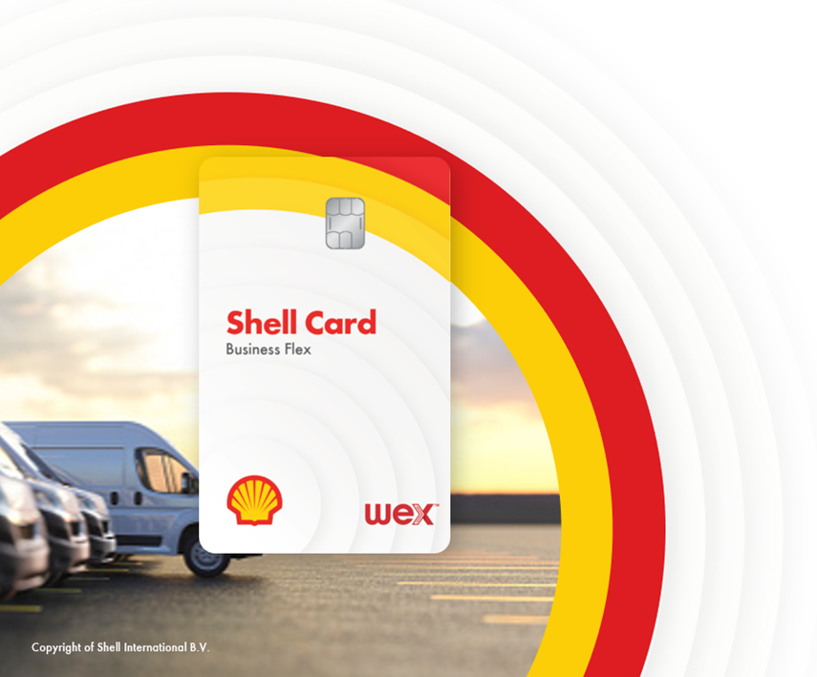On March 3rd, Shell Fleet Solutions is launching the new and improved Shell Card! The new fleet card features an updated design, exciting benefits, and a refreshed marketing approach to drive more sales, volume, and convenience retail to Shell stations.

To build on the momentum of the new card launch and help boost your fleet customer business, consider doing the following optional actions.

* Enroll your sites in the B2B rebate program – offer a 3 or 5 ¢/gal discount to Shell Card Business Flex users to encourage them to fuel at your stations. Participating sites are highlighted on our station locator and on the DriverDash app. Contact [Lindsay.Aston@shell.com](mailto:Lindsay.Aston@shell.com) to learn more and enroll.
* Sign up for merchant funded rebates – build a strategic relationship with a local customer by offering an exclusive discount for their fleet. Contact [Lindsay.Aston@shell.com](mailto:Lindsay.Aston@shell.com) to learn more and sign up.
* Purchase and display the new Shell Card POP from Pointsmith (coming soon!)

As a reminder, fleet drivers purchase 60% more fuel and 117% more convenience retail per transaction compared to a typical customer. Visit the [Fleet MarketHub Page](https://eur02.safelinks.protection.outlook.com/?url=https%3A%2F%2Fwww.markethub.shell.com%2Fcontent%2Fnextgen%2Fshell%2Fus%2Fen_us%2Fws%2Ffuels%2Fportal%2Fhome%2Fmarketing%2Fcards-payments%2Ffleet-cards.html&data=05%7C02%7CAnna.Malygin%40shell.com%7Ce2a885fb4714441b5da508dd3b4363f5%7Cdb1e96a8a3da442a930b235cac24cd5c%7C0%7C0%7C638731882796645253%7CUnknown%7CTWFpbGZsb3d8eyJFbXB0eU1hcGkiOnRydWUsIlYiOiIwLjAuMDAwMCIsIlAiOiJXaW4zMiIsIkFOIjoiTWFpbCIsIldUIjoyfQ%3D%3D%7C0%7C%7C%7C&sdata=QW6sEXietlkpx7TTZpp2gh%2FNv5mDzx494Ri3EWF%2BlAE%3D&reserved=0) to see more details on the upcoming changes.

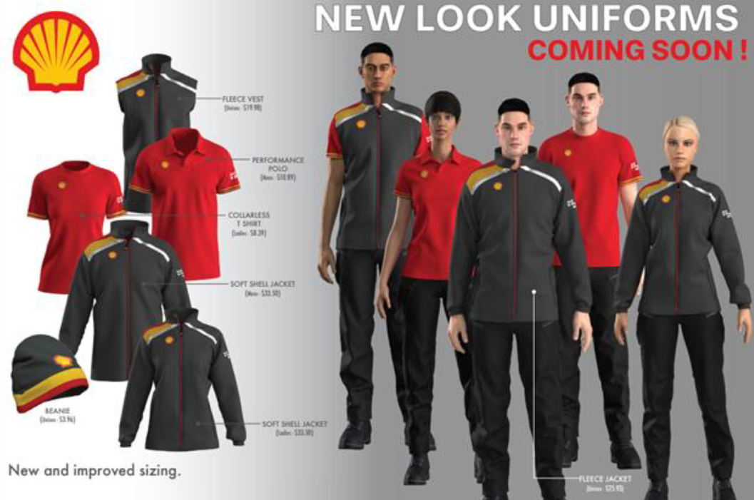**New Uniforms: Coming Soon!**

Starting February 3, 2025, new uniforms will be available to order on [www.shellusauniforms.com](http://www.shellusauniforms.com).

**Shell Showcar Program**

Leverage the showcar for: grand opening events, special promotions, customer appreciation days, and MORE!

****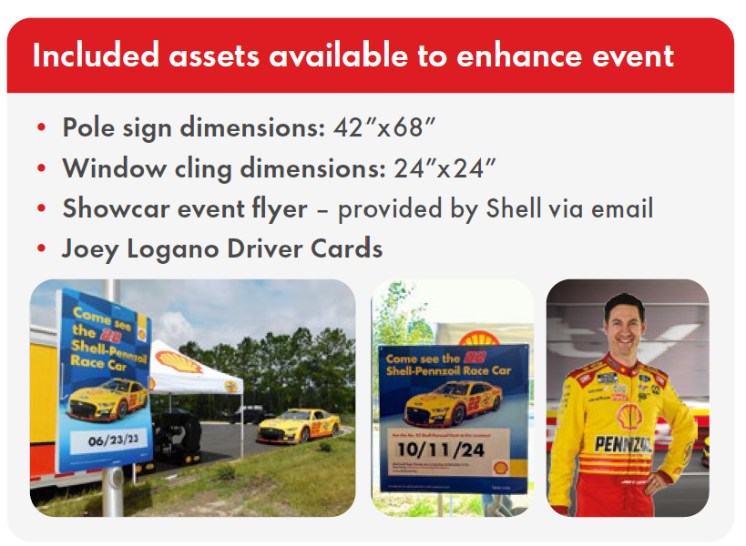The #22 Shell-Pennzoil Ford NASCAR is

driven by three-time Cup champion Joey

Logano! A showcar event can help educate,

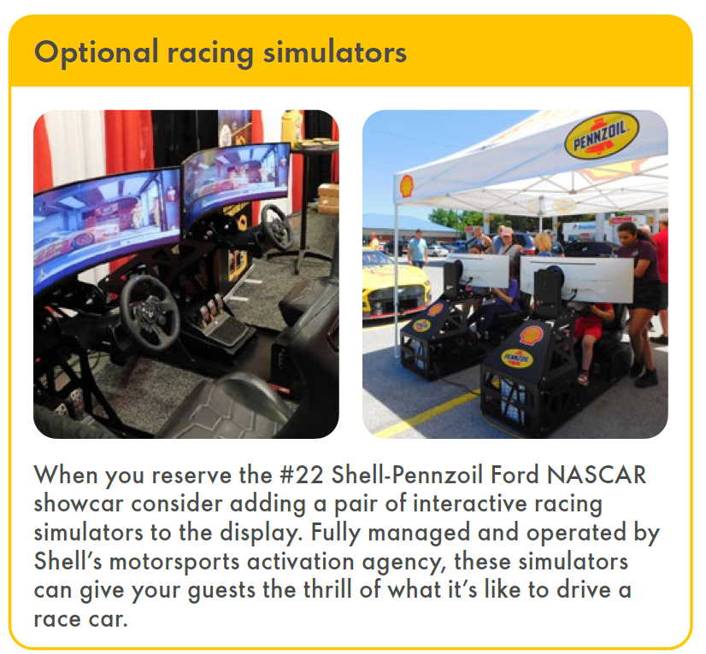highlight, and differentiate Shell and the

brand from competitors.

Please contact Kendra ([kendra@sd.team](mailto:mkendra@sd.team)) for scheduling or visit <https://shell.sd.team/showcar>