Subscribe to the CTA newsletter to receive it directly via email. Click here to find out more.
February 25, 2025

The Power of Loyalty

Shell and the Fuel Rewards® program are excited to share with you ‘The Platinum Proposal’
Fuel Rewards® members with Platinum Status have access to monthly rewards like sweepstakes to amazing experiences, giveaways, and extra ways to save. Join Platinum Status member, Jesus, winner of the “Choose Your Adventure” sweepstakes to New York City, as he travels to “The Big Apple” with his girlfriend and asks her a life-changing question they’ll never forget.

Click here to learn more about Platinum Status and the Fuel Rewards® program.


Fuel Rewards® Platinum Status – March Offers and Experiences
In addition to saving at least 10¢/gal and earning 2x on In-Store Rewards, a special benefit for Fuel Rewards® members with Platinum Status is access to special VIP offers and experiences. In March, we will have an Apple eGift Card sweepstakes.


Apple eGift Card Sweepstakes
Fuel Rewards members with Platinum Status can enter a sweepstakes for a chance to win a $25 Apple eGift Card.
- 1,000 winners
- Sweepstakes dates: March 3 – March 16

In-Store Rewards - March Offers
We are excited to introduce the next Power Deal: Buy 2 Celsius, earn 7¢/gal. Celsius has been growing market share in the energy drink category. As a reminder, members with Platinum Status earn 2x on all In-Store Rewards offers.
- Power Deal – Buy 2 Celsius, earn 7¢/gal
- Buy any 1 Deer Park (1.5 L) products, earn 7¢/gal
  - States applicable: AL, GA, SC, NC, VA, DC, MD, DE, WV, KY, TN, PA
- Buy any 1 Arrowhead (1.5 L) products, earn 7¢/gal
  - States applicable: WA, OR, CA, NV, ID, MT, WY, UT, CO, AZ
- Buy any 2 100% Natural Spring Waters (1.5 L), earn 10¢/gal
  - Ozarka - States applicable: NM, TX, OK, KS, LA, AR, MO
  - Ice Mountain - States applicable: ND, SD, NE, MN, IA, MI, WI, IL, IN, OH, MO
  - Zephyrhills - States applicable: FL
  - Poland Springs - States applicable: MA, ME, NH, VT, NY, NJ, CT, RI
- Buy any 2 Deer Park (1 L) products, earn 7¢/gal
  - States applicable: AL, GA, SC, NC, VA, DC, MD, DE, WV, KY, TN, PA
- Buy any 2 Arrowhead (1 L) products, earn 7¢/gal
  - States applicable: WA, OR, CA, NV, ID, MT, WY, UT, CO, AZ
- Buy any 2 100% Natural Spring Waters (1 L), earn 5¢/gal
  - Ozarka - States applicable: NM, TX, OK, KS, LA, AR, MO
  - Ice Mountain - States applicable: ND, SD, NE, MN, IA, MI, WI, IL, IN, OH, MO
  - Zephyrhills - States applicable: FL
  - Poland Springs - States applicable: MA, ME, NH, VT, NY, NJ, CT, RI
- Buy 2 Sparkling Ice Caffeine (16 oz), earn 5¢/gal
- Buy 1 Saratoga 16oz/28oz, earn 5¢/gal
- Buy 2 Trident Singles, earn 5¢/gal
- Buy 1 King Size Reese's 2.25oz-3.5oz, earn 2¢/gal
Click here to view the reference materials including high resolution artwork, POP templates for local printing, flyer with UPCs, change mat inserts and Wayne Anthem dispenser slides. Check the Fuel Rewards® or Shell App regularly to view additional short-term digital only offers.

Help drive consumer awareness and increase your c-store sales by printing the POP and displaying the In-Store Rewards products near the register. If you have any questions, please contact mark.dyer@shell.com

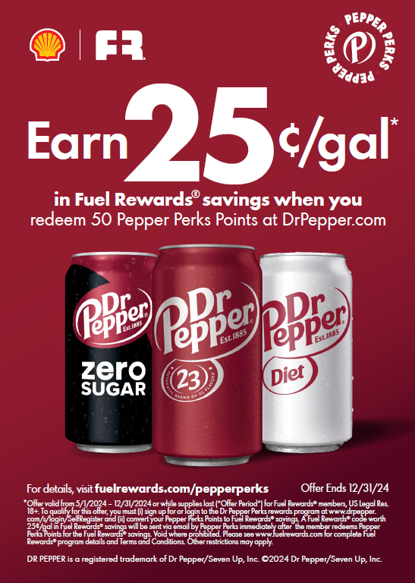
Dr Pepper – Pepper Perks Program Update

The Fuel Rewards® program’s limited-time collaboration with Dr Pepper recently expired. Please remove any promotional POP that is displayed. Throughout the offer period, we gained valuable new members into the Fuel Rewards® program. We look forward to exploring new opportunities with Dr Pepper in the future.


March Session: 2025 Leading with Loyalty and The Giving Pump Campaigns
Click here to join us March 4 at 11 AM CST for the Shell Mobility Academy Webinar.

This session will cover exciting details about the Leading with Loyalty campaign that will kick off on April 21. Make sure to join to learn about the consumer offers associated with this campaign, which includes a new customer acquisition offer, more partner offers, a c-store promotion, and an increased media investment. Additionally, the webcast will detail steps to take to best activate this campaign at sites. (Spoiler alert: There will be Site Staff Rewards giveaways during the campaign including signed racing merchandise from reigning 3x NASCAR Cup Series Champion and Shell-Pennzoil driver Joey Logano, gift cards and grand prize race tickets!)
This session will also kick off this year’s The Giving Pump enrollment information, including a new turnkey Charity National Partner!
Shell Program Updates

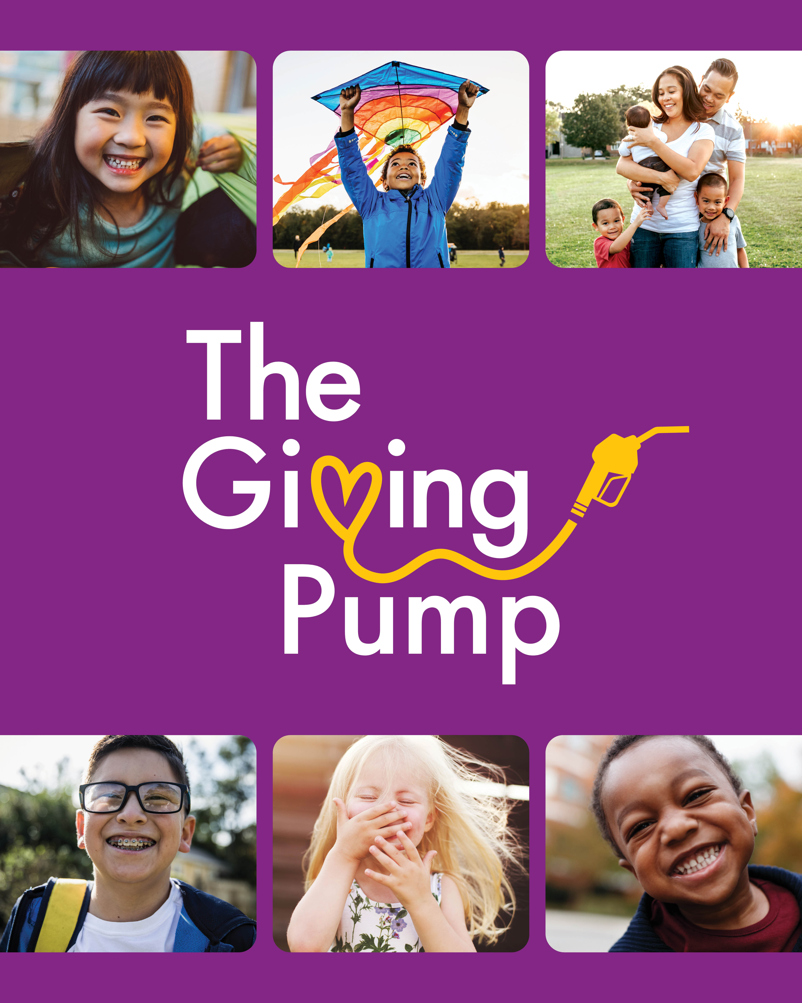
The Giving Pump 2025: Enrollment Opening Soon!
The Giving Pump is back for another impactful year! Join us on the upcoming Shell Mobility Academy to learn about this year’s program, including our new turnkey charity partner, a marketing campaign highlighting the stories of impact – featuring wholesalers and the charities they support – and how you can participate. Save the following link to your calendar to join the Shell Mobility Academy webcast on March 4th at 11am CST. Be a part of the program that drives change in communities across the county – don’t miss it!

Reminder: New Shell Fleet Cards Coming March 3
On March 3rd, Shell Fleet Solutions is launching the new and improved Shell Card! The new fleet card features an updated design, exciting benefits, and a refreshed marketing approach to drive more sales, volume, and convenience retail to Shell stations.
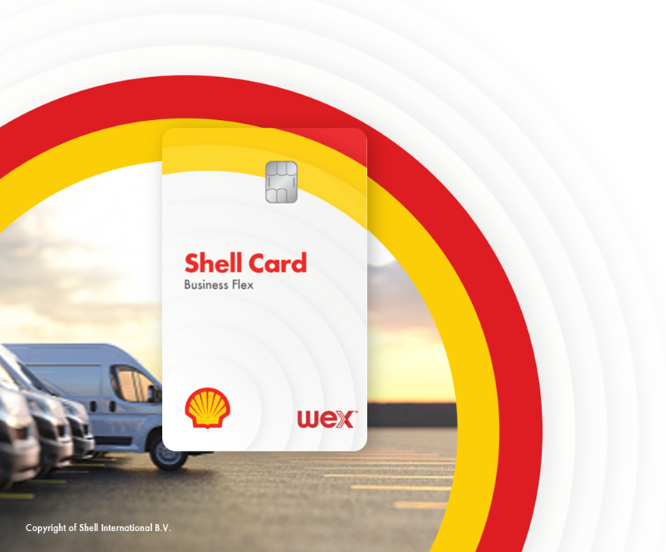
To build on the momentum of the new card launch and help boost your fleet customer business, consider doing the following optional actions.

- Enroll your sites in the B2B rebate program – offer a 3 or 5 ¢/gal discount to Shell Card Business Flex users to encourage them to fuel at your stations. Participating sites are highlighted on our station locator and on the DriverDash app. Contact Lindsay.Aston@shell.com to learn more and enroll.
- Sign up for merchant funded rebates – build a strategic relationship with a local customer by offering an exclusive discount for their fleet. Contact Lindsay.Aston@shell.com to learn more and sign up.
- Purchase and display the new Shell Card POP from Pointsmith (coming soon!)

As a reminder, fleet drivers purchase 60% more fuel and 117% more convenience retail per transaction compared to a typical customer. Visit the Fleet MarketHub Page to see more details on the upcoming changes.

Shell V-Power® NiTRO+ Performance Tour
Leverage the Shell V-Power® NiTRO+ Premium Gasoline Performance Tour at your next engagement or site event to learn about our Shell premium gasoline that helps your engine achieve maximum performance by removing up to 100% of performance-robbing deposits * -- Shell V-Power® NiTRO+.
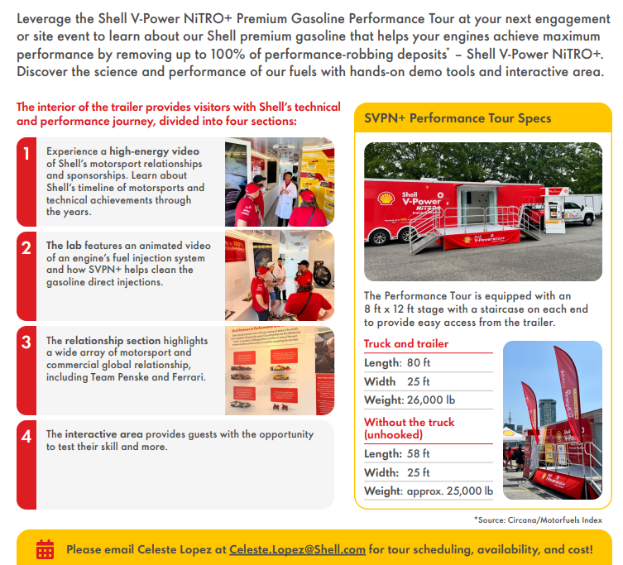
Discover the science and performance of our fuels with hands-on demo tools and interactive area.

Shell Solutions Center

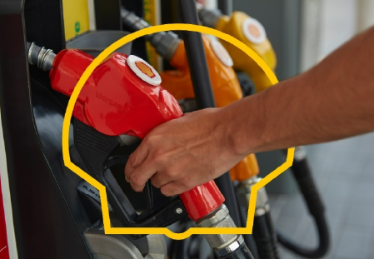

If you receive a request from a Presidential & Contamination specialist regarding a Potential Non-Compliance case, it is required to provide the affected BOL copies and confirm if there were any known issues during the test sample timeframe.

Potential Non-Compliance Cases are sample quality assurance reports that the RFGSA (RFG Survey Association: About Us) has found non-compliant in terms of ethanol, RVP, and sulfur content and must be addressed immediately.

You may also visit the Shell Markethub Help & Support page for Shell Solutions Center for Potential Non-Compliance FAQs.

