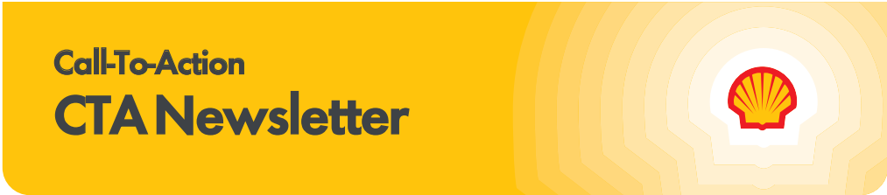

Subscribe to the CTA newsletter to receive it directly via email. Click here to find out more.
April 29, 2025
Featured Topics
Fuel Rewards® New Member Offer Campaign Launch
Following the April 21 launch of the Fuel Rewards® New Member Offer Campaign, we wanted to highlight some of the new media tactics that went live in the past week. This year, we introduced several exciting new partners that offer innovative, high impact media units which will help to reach broader audiences and make signing up for the Fuel Rewards® program easier than it’s ever been. Take a look at some of the placements below!
Bleacher Report is a digital media company that focuses on sports content. Capitalizing on one of the biggest football moments of the year, we sponsored the takeover of the Bleacher Report website and mobile app on Tuesday April 22. Video and banner ads were displayed throughout the pages, educating the Bleacher Report audience on the Fuel Rewards® new member offer and encouraging them to sign up for the program.
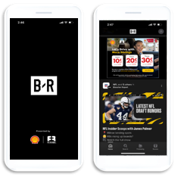
We also sponsored the “Draft Spectacular” episode of Gridiron Heights, an original animated series that runs weekly on the platform. Check it out on Instagram here!
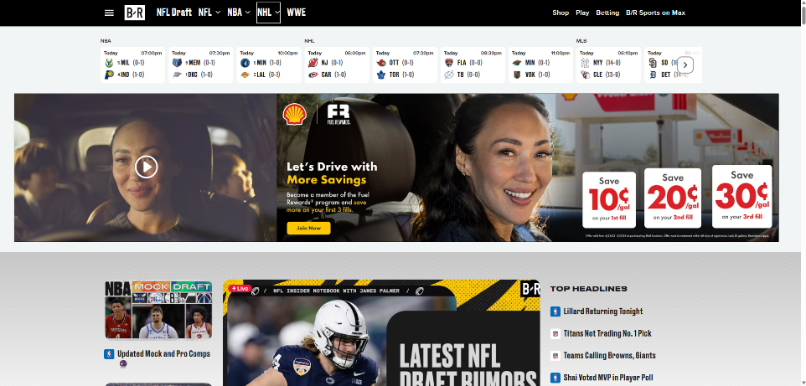
Roku is a streaming platform that offers live and on-demand content. Leveraging Roku’s “Ok-to-Text” feature, we are running a high impact video ad through July 31, 2025 that prompts viewers to input their phone number to sign up for the program. Once they submit their number, they’ll receive a text with a link that takes them directly to the registration page.
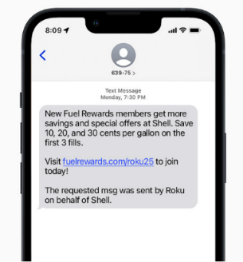
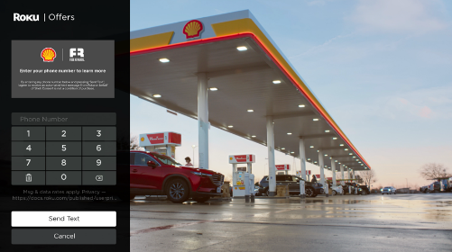
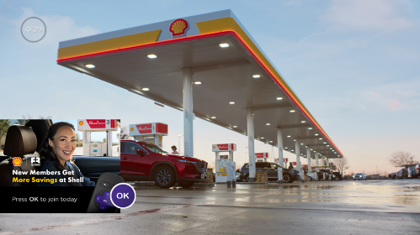

iHeart Radio is an audio streaming platform where people can listen to their favorite radio stations and podcasts. Now through June 30, 2025, we are running a Motion Activated Ad where listeners hear a Fuel Rewards® audio commercial and are prompted to shake their phone to sign up. Upon shaking their phone, the listener is brought to the registration page, making sign up quick and easy. We’ve also produced several radio spots that will run on iHeart Radio and other audio streaming platforms. Check it out on the MarketHub Advertising page!
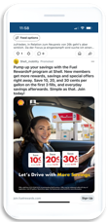
Reddit is a social media platform with user-created communities called “sub-reddits” where people post content and engage in discussions. On launch day, we sponsored the takeover of relevant sub-reddits where our target audiences were likely to be (i.e. auto). Clickable banner ads were visible throughout the pages for users to engage and easily click to get to the registration page. Ads on Reddit will continue to run throughout the year.
Connected TV is a digital media tactic that allows us to feature a Fuel Rewards® program ad with a clear call to action to sign up for the program. Viewers across live TV streaming platforms will see our ads as they’re watching their programming and will be prompted to scan a QR code that will take them directly to the registration page.
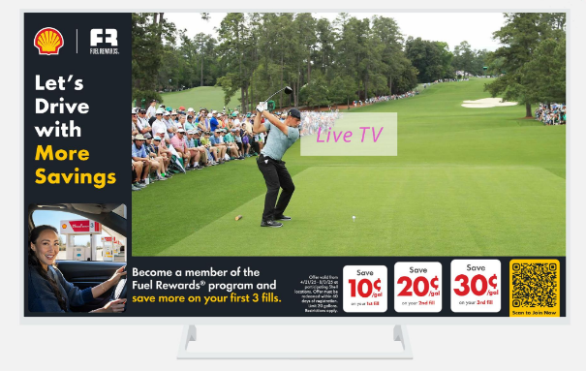
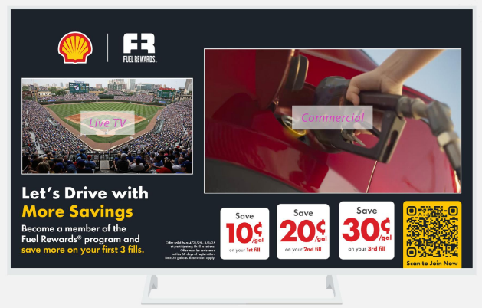

To learn more about the Fuel Rewards® New Member Offer campaign, including downloadable assets and a full campaign overview pack, view the Advertising MarketHub page.

'MORE' Fuels Campaigns
We're thrilled to announce our new Shell V-Power® NiTRO+ campaign launched in tandem with the Loyalty campaign on April 21. This integrated strategy reinforces the benefits of Shell’s premium fuel and is running on multiple channels that have been proven to drive consumers to Shell stations. To further link our Premium fuel with the Shell Fuel Rewards® program, we've designed a creative strategy that highlights how customers get MORE savings and performance at Shell. This collective effort is intended to increase foot traffic to your stations through using data and insights to determine the best channel. To learn more about the campaign and marketing channels, please view the Shell V-Power® NiTRO+ Campaign Overview deck on MarketHub.


May Session: Shell Ready and Site Staff Rewards
Click here to join us May 6 at 11 AM CST for the Shell Mobility Academy Webinar.
Shell is excited to announce Shell Ready, a new program to streamline site’s onboarding experience. This new program includes onboarding guidance and resources for new sites seeking to learn more about Shell programs and guidance on program implementation. Features include a customized onboarding journey, program related resources, steps to implementation, dealer invitation management, and helpful contact information.
During the webinar, we will review all features and how you can leverage Shell Ready to streamline onboarding of your new and existing sites.
Additionally, the session will cover the Site Staff Rewards program, including reminders on the program, new feature enhancements, and exciting upcoming contests.
The Power of Loyalty
Fuel Rewards® Platinum Status - May Offers and Experiences
In addition to saving at least 10¢/gal and earning 2x on In-Store Rewards, a special benefit for Fuel Rewards® members with Platinum Status is access to special VIP offers and experiences. Help make Mother’s Day special with these 2 great offers.

- Visa® Gift Card Sweepstakes
Reward someone special in your life. Enter the sweepstakes and be one of 1,000 winners of a $25 U.S. Bank Visa® Reward Card.
  - Sweepstakes ends May 15



- Enhanced Dining Offer
During the month of May, Platinum Status members can earn a one-time bonus of 50/gal reward when they spend $50 with a linked payment card at participating restaurants. The 50¢/gal bonus reward is in addition to the standard 10¢/gal reward earned through the dining program. Both of these stack with the member’s Platinum Status meaning they will save at least 70¢/gal.

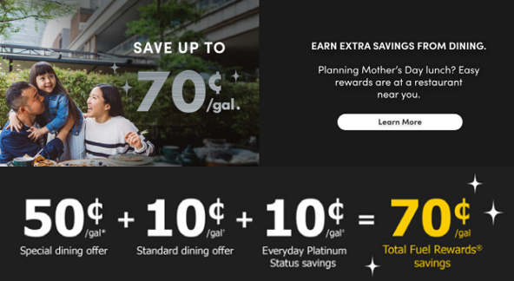

In-Store Rewards – May Offers
Help drive consumer awareness and increase your c-store sales by printing the POP and displaying the In-Store Rewards products near the register. As a reminder, members with Platinum Status earn 2x on all In-Store Rewards offers.

- Power Deal – Buy 3 100% Natural Spring Water 700ml, earn 10¢/gal
- Buy 1 100% Natural Spring Water 1.5L, earn 5¢/gal
- Buy 2 Sparkling Ice Caffeine 12-16oz, earn 5¢/gal
- Buy 2 Any King Size Choc 2.25-3.5oz, earn 5¢/gal
- Buy 1 Splash Refresher Sparkling Water 16oz, earn 5¢/gal
- Buy 2 Tic Tac 1.7 oz packs, earn 5¢/gal
Click here to view the reference materials including high resolution artwork, POP templates for local printing, flyer with UPCs, change mat inserts and Wayne Anthem dispenser slides. Check the Fuel Rewards® or Shell App regularly to view additional short-term digital only offers.

If you have any questions, please contact mark.dyer@shell.com

Fuel Rewards® Promotional Cards
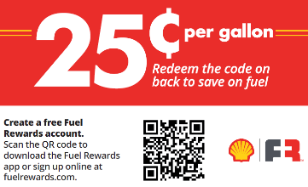
Are you hosting an event or looking for ways to incentive your employees? Wholesalers may order Fuel Rewards® promotional scratch-off cards in denominations of 5¢, 10¢, 15¢, 20¢ or 25¢ per gal. The Fuel Rewards® member scratches off the foil seal on the back of the card to reveal their code. The code may be loaded to their account through the Fuel Rewards® app or by logging into their account at www.fuelrewards.com/code. Once the code has been loaded, it should be immediately available to redeem. If the customer is not already a Fuel Rewards® members, they may scan the QR code on the front to quickly join.

Steps to ordering cards
- Contact Mike_Beck@Archway.com at Archway/Teraco
  - Send him the card denomination
  - Quantity
  - Expiration date
    - Date the cards must be loaded by. Once the code has been loaded, the member will have the remainder of the current month + the next full month to redeem the reward.
  - Fuel Rewards participant ID for billing reward redemptions
    - Participant ID can be found on your Fuel Rewards® settlement reporting
  - Shipping address
- There is a $50 cost for printing + shipping.
  - This can be billed to a credit card
- The wholesaler will also be responsible for the cost of the rewards that are redeemed.
  - This cost will appear in the Fuel Rewards® settlement report.
- It usually takes about 2 weeks to fill the order.

If you would like to request a spin wheel to support your event, contact Pointsmith at (800) 762-5213 or email shellemailorders@pointsmith.com.
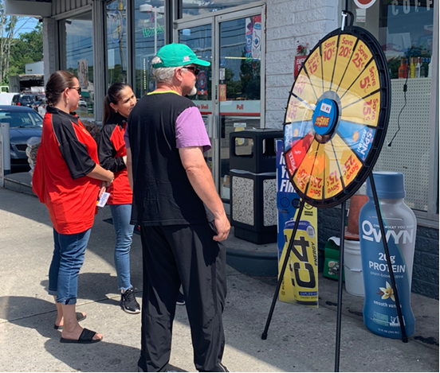
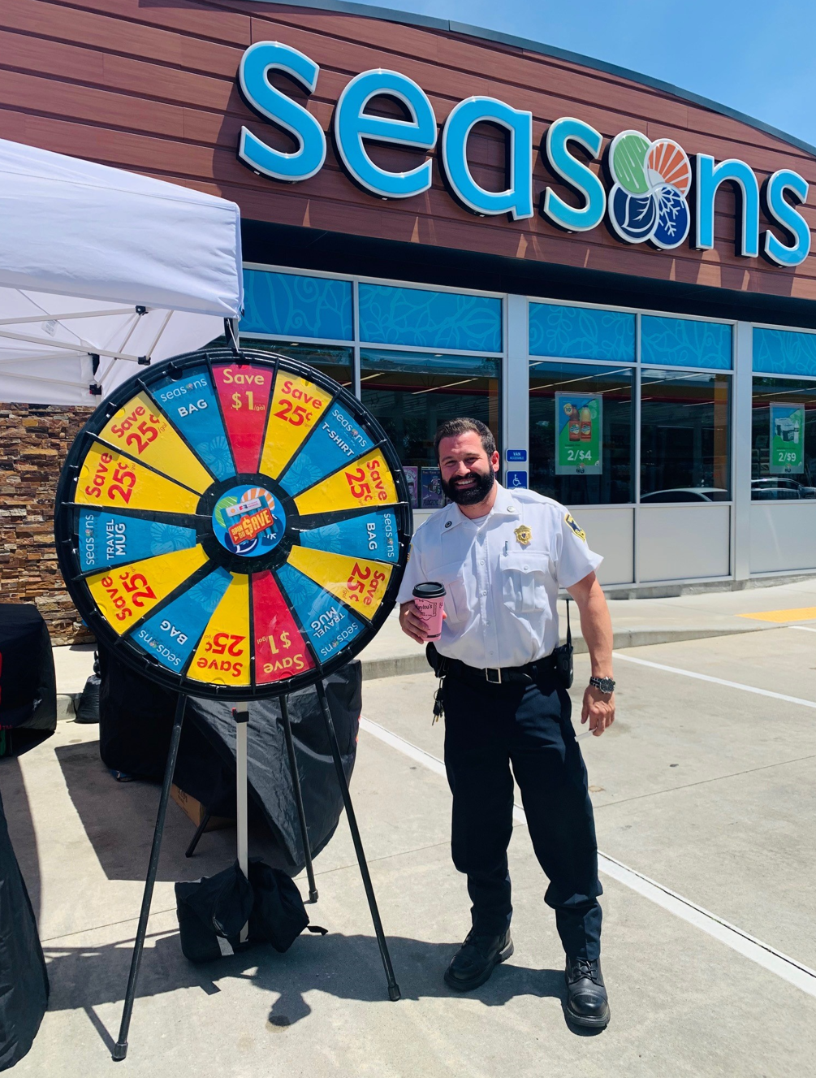

Click here to view the information on MarketHub.

Time to Reorder Fuel Rewards® Brochures
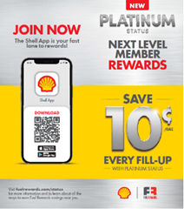
As a reminder, the Fuel Rewards® brochures are no longer on auto replenishment. When sites run low on Fuel Rewards® brochures they should contact Pointsmith.

- Contact Pointsmith at 1-800-762-5213 or send an email to Shellemailorders@pointsmith.com.

Partner Update: Bank of America Rewards Program
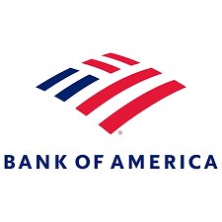
We would like to inform you that Bank of America is sunsetting their current “Partner Rewards Program” and will be leaving the Fuel Rewards® effective June 25, 2025. We thank Bank of America for their collaboration and wish them all the best as they begin development on their new rewards system. As we move forward, we remain committed to enhancing our rewards program and delivering outstanding value to our members.
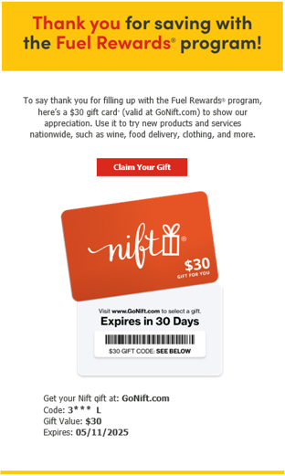
Thanking Members for Saving with the Fuel Rewards® Program
Fuel Rewards® is working with GoNift.com to say thank you to members. After fueling, Fuel Rewards® members may receive an email inviting them to claim a gift. When they click the link, they will be presented with options to save on new products or services nationwide, like food, wine clothing and more. If there are any questions, please contact Fuel Rewards® member support at support@fuelrewards.com or call (888) 603-0473.

Shell Program Updates
Mystery Motorist Program (MMP) Period 2
Mystery Motorist Program (MMP) Period 2 starts on Thursday, May 1. To help wholesalers and sites prepare for these shops, we’ve included some helpful reminders below.

- Timing
  - Period 2 (P2) shops will begin on May 1 and conclude on July 31.
- MMP Shop Notifications
  - Make sure you don’t miss the advance shop notifications! Wholesalers and dealers can subscribe themselves (or other team members) to receive these notification emails using the MarketHub subscription tool. Notifications are sent out 30 days before the shop will occur. View the Subscription How-To Guide on the MMP MarketHub Page to learn more.
- To place your site on temp inactive
  - Detailed instructions can be found in the MMP portal user guide “MMP 0 – Help and Resources” on the MMP Portal.
- To place an image essential temporary exemption
  - Before the shop you can find the link located in the body of the prenotification email or if placing after the shop occurs, you can find the link at the top of the Image Essential section of the site scorecard
PMTDR
Nashville Highlights!
- “I’ve never felt so important in my 16 years of working. Shell has made me want to go the extra mile in my career.”
- “Being a new manager, it helped me see things I have never thought about, and I also learned about programs I never knew of”
- “We were so impressed by not only the sincere gratitude and recognition we were shown by Shell, but the Shell management team were so down to earth and personable themselves.”

Those were just some of the comments from PMTDR Nashville attendees where nearly 400 frontline staff, Dealers and wholesaler hosts gathered for a few days of recognition, celebration, and fun!

Check out the highlights by region:
- Gulf Coast Region
- Midwest Region
- Northeast Region
- West Region
- Video… Coming soon!
- Nashville Highlight PowerPoint slides for team meetings
- 2026 Trip Destinations!
Based on the end of year rank, site winners and their guests will be traveling to these exciting locations! Use these links for internal announcements, team meetings, office doors or break areas.
  - PMTDR Top 5% Local Destination
    - Video 2026 PMTDR Destination Top 5%
    - 2026 Poster 2026 PMTDR Destination Top 5% Poster
    - Vision Board 2026 PMTDR Vision Board Top 5%
    - 2026 Local trip dates: March 30 – April 2, 2026
  - PMTDR Top 1% Smiling Stars Destination
    - Video Smiling Stars 2026 Reveal Video on Vimeo
    - Poster Smiling Stars_2026_Poster
    - 2026 Smiling Stars trip dates: May 19 – 22, 2026

Trip qualification is determined by end-of-year rank based on the 2025 PMTDR Scorecard.

Still not participating in PMTDR but want to start now?
Email the location numbers you would like to enroll in the 2025 program to Kathie.Corner@shell.com

PMTDR Annual Program Fee Billing Reminder
The 2025 PMTDR annual program fee is $425 per site and will be billed at the end of May/beginning of June. The program fee is eligible for 50% co-op reimbursement. If you wish to make any changes to your enrolled sites prior to the annual billing, please contact your Territory Manager or Kathie.Corner@shell.com for assistance.
Coming soon … First period rank and the top 10%! The MMP P1 cure window closes on May 15. PMTDR ranking will run with the final MMP scores and will be published at the end of May.

10 Days left to enroll in The Giving Pump 2025
Act now before it’s too late! Enrollment for The Giving Pump 2025 campaign closes on Friday, May 9. Don’t miss out on the chance to make a meaningful impact on your community while driving customers to your sites. By enrolling, you’ll not only receive The Giving Pump dispenser decals and POP kits but will benefit from the national marketing campaign. This year, the campaign will highlight the stories of impact, featuring wholesalers and the charities they support on platforms like YouTube, Spotify, iHeart Radio, GasBuddy, Facebook, Instagram, Snapchat, TikTok, PR, GSTV and customizable local marketing materials. Access The Giving Pump Enrollment portal on the MarketHub Force for Good page.

Fuel Rewards® members save MORE on Winning Wednesdays!
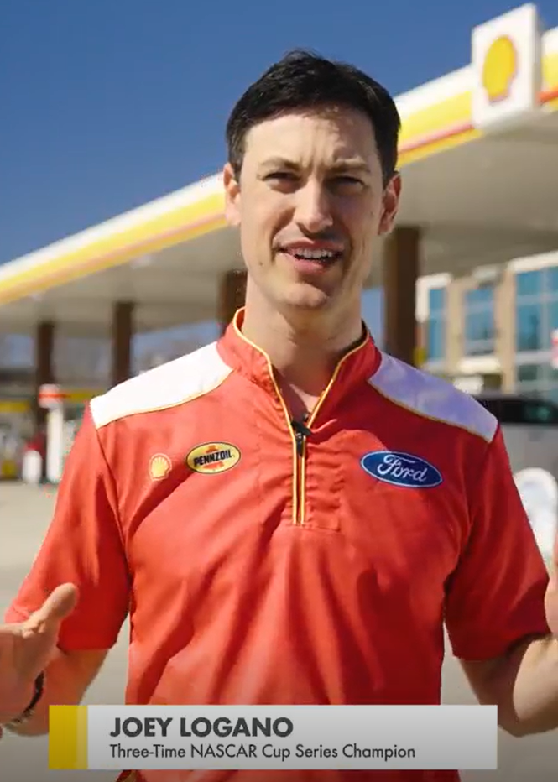
Beginning May 21, when NASCAR’s No. 22 Shell-Pennzoil team and Joey Logano win a race, consumers and fans can score savings at the pump. Fuel Rewards® members who activate the offer in the Shell App will save 22¢/gal on the Wednesday following a race win when they fill-up on any grade! Click here to view the promotional video!


How It Works: Fuel Rewards® members must opt-in via Shell App promo tile and once they do so the cpg discount will be shown in Fuel Rewards balance right away.

Ask your Territory Manager for more details. Consumers can sign up to become a Fuel Rewards® member here. Terms and conditions apply for the offer.

MORE wins mean fueling performance on and off the racetrack.

Shell V-Power® NiTRO+ Performance Tour: Experience Premium Gasoline
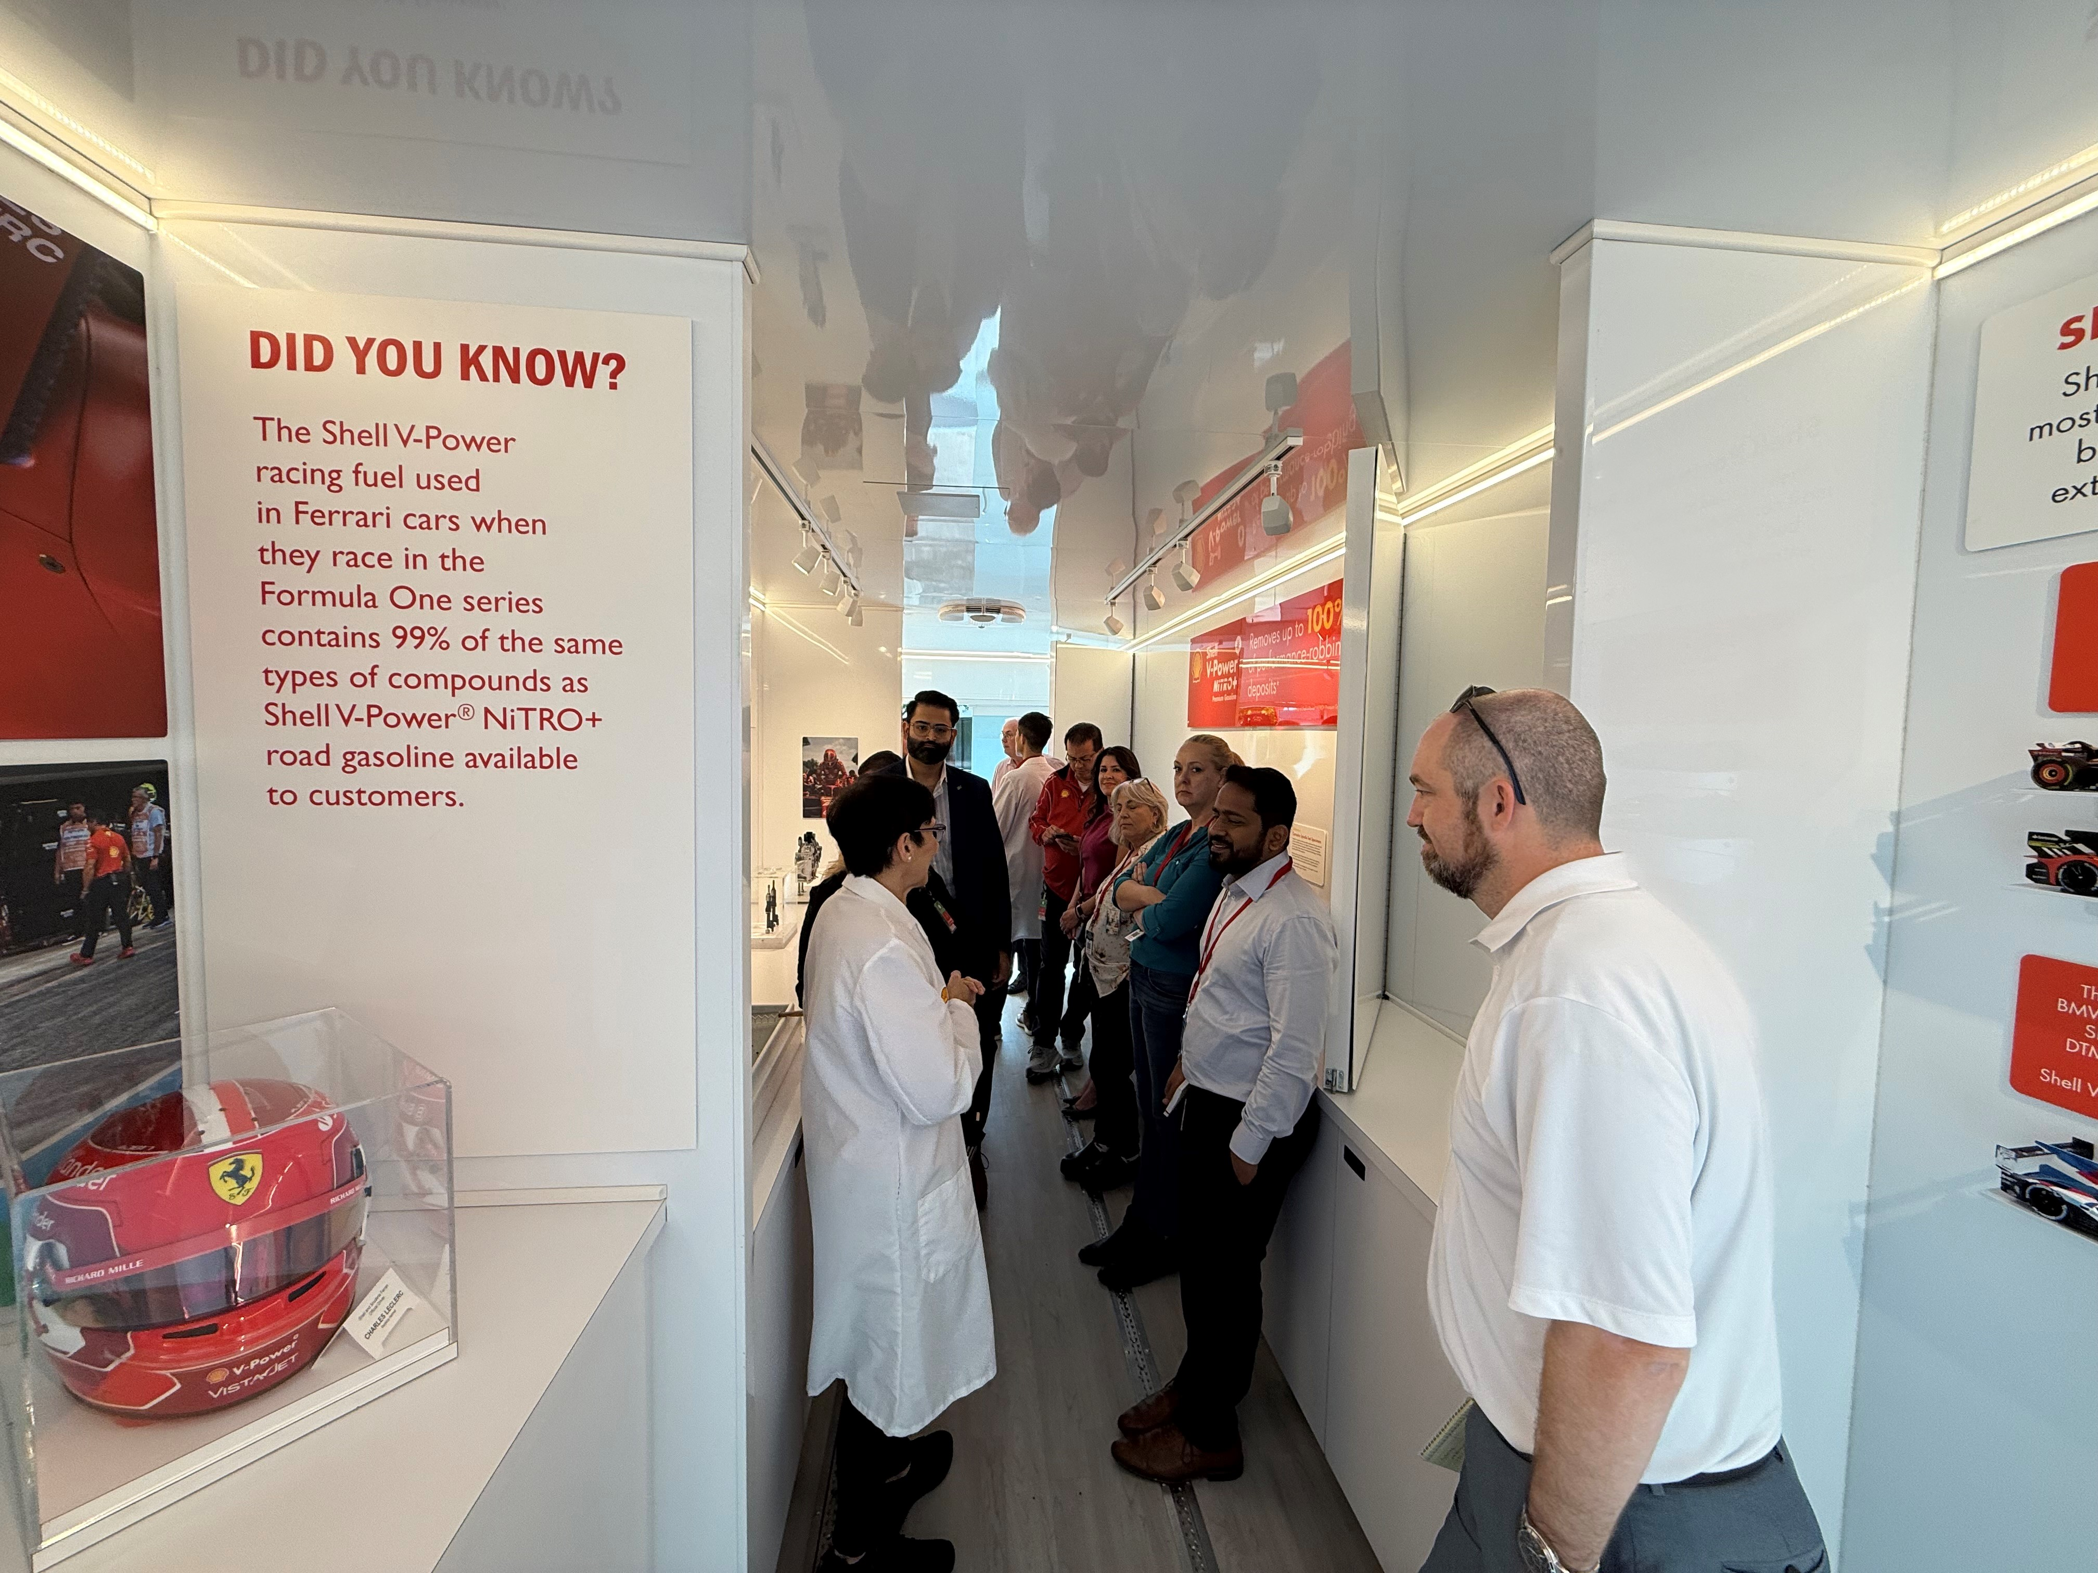
The Shell V-Power® NiTRO+ Performance Tour showcases Shell's premium gasoline, which helps engines achieve maximum performance by removing up to 100% of performance-robbing deposits. The tour features hands-on demo tools, an interactive area, and a high-energy video highlighting Shell’s motorsport relationships with teams like Team Penske and Ferrari. Visitors can explore Shell's technical achievements through animated videos and interactive exhibits. For scheduling and cost details, please contact Celeste Lopez at Celeste.Lopez@Shell.com.

