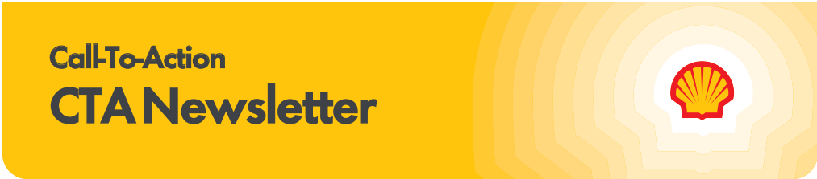

Subscribe to the CTA newsletter to receive it directly via email. Click here to find out more.
September 30, 2025
Featured Topics

Diamond Deal: T-Mobile for Business

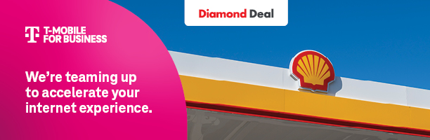

Check out the New Offer from T-Mobile for Business!
T-Mobile for Business Diamond Deal offers a 5G Enterprise Grade Internet solution for Shell retailers that delivers wireless connectivity that keeps operations running, whether you’re facing equipment issues, service interruptions or infrastructure challenges. Leveraging America’s largest and fastest 5G network. Click here to check out the microsite.

The Diamond Deal includes reliable 5G Business Internet starting at just $110/month with the following:

■ Premium Service free router refresh every 3 years
■ Premium Installation includes indoor or outdoor install (determined by install team)
■ Premium Hardware includes Cradlepoint Router ($1,200 value)

Disclaimer: Capable device required for 5G; coverage not available in some areas. Some uses may require a certain plan or feature; see T-Mobile.com. Fastest: Based on analysis by Ookla® of Speedtest Intelligence® data of national Speed Score results incorporating 5G download and upload speeds for 1H 2025. Ookla trademarks used under license and reprinted with permission.

2025 Giving Pump Campaign’s Real Impact!
The Giving Pump campaign is in full swing and the energy across the network is inspiring. From local news stories to heartfelt community moments, your efforts are driving real impact. This campaign thrives because of wholesalers and the charities you champion.
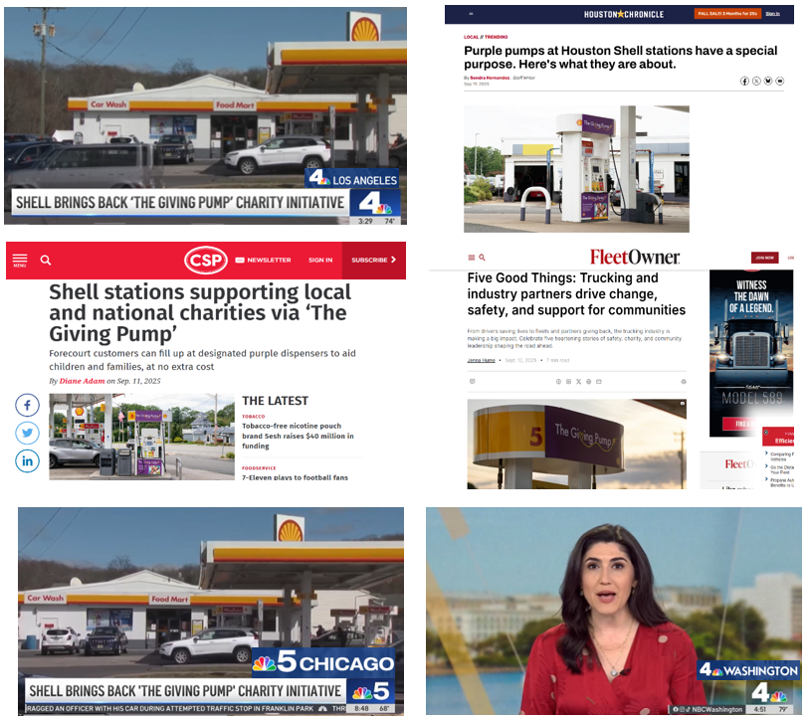
Media Buzz
The Giving Pump has been featured in extensive national media and 91 local media outlets and is generating over 500 million impressions and counting! From small-town papers to major lifestyle magazines spotlighting your sites and the causes you support are being celebrated far and wide.

Real Stories, Real Impact
This year, we’re continuing to shine a spotlight on the people behind the purple pumps. Click here to check out our featured video on Joseph Boente & Sons, showcasing how one wholesaler’s commitment to local giving is making a lasting difference.

10-20-30 Campaign Extended: Keep the Momentum Going
Since launching the 10-20-30 New Member Offer campaign, we’ve seen remarkable momentum—double-digit growth in Fuel Rewards® enrollments and over 2 million new members joining the program. These new members are making a real impact, driving more gallons at your sites and increasing in-store sales. On average, each Fuel Rewards® member brings 360 gallons in fuel purchases and $115 in-store spend every year.

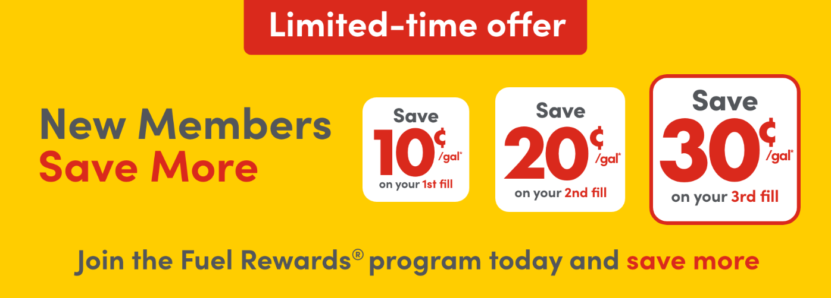
With these strong results, we’re excited to extend the campaign through the end of the year. This is a great opportunity to keep building on our shared success and capture even more value from loyal, engaged customers.

Along with this extension, the Site Staff Rewards Race to Win contest will also be extended. We are pleased to announce the contest’s Grand Prize # 3, which is Race to Win Pit Stop. The Race to Win Pit Stop includes a full set of (4) Tires and an Oil Change. Two (2) winners will choose from a limited list of participating dealers within 30 miles of their home or work for the installation. Prize distribution will be coordinated by Shell. Click here to learn more about Race to Win.

Important Updates

MarketHub 2.0 is Coming This Fall!
Thank you to those who participated in the series of informative webinars designed to help you navigate and maximize your use of the new Shell MarketHub 2.0. If you missed those sessions or want to revisit them, you can access the recordings on the Shell Mobility Academy MarketHub page.
Key reminders to ensure your team is ready to transition to MarketHub 2.0:
- Confirm your customer admin account within MarketHub is active.
- Review subscriptions and account permissions for yourself and your organization (including dealers) to ensure the correct individuals will receive and have access to what they need for the upcoming launch.
- Link to Managing Subscriptions
- Link to Managing Users – Double check that accounts do NOT share an email address
Great news! Subscriptions in 1.0 will carryover to 2.0, but keep in mind there will be cutoff dates which we will communicate for any adds/edits to existing subscriptions before the migration.
For questions regarding account set ups, please reach out to the Shell Solutions Center at ssc@shell.com.
- Ensure timely volumes entry for incentives: The last day to enter volumes, including for September, in Shell MarketHub 1.0 is Monday, October 13.
Stay tuned for additional communications over the coming weeks, including connection instructions to link to the new API, email log in instructions, and short training videos available on Shell MarketHub 1.0. For now, you can click here to view a list of Shell MarketHub reports that will be available through API.
We look forward to this exciting next generation of Shell MarketHub coming soon! Click here to view the MarketHub 2.0 highlights video.

Card Transaction Support Update
Effective 9/1, please contact the Shell Solutions Center for all Card Transaction Inquiries. This applies to all Settlement document types. Email ssc@shell.com or call 1-800-Hi-Shell > Option 2 > sub option 1.

Now it is even easier to enroll in the Shell Fleet Rebate Bonus Location Program!


Do you have fleets in your trade area? Then don’t delay and enroll in the Shell Fleet Rebate Bonus Location Program via the new online portal!

Fleet customers buy more convenience store, car washes, and fuel than typical consumers. Join the over 3,000 Shell sites already enrolled in the Rebate Bonus Location Program and offer Shell Card Business Flex customers a 3¢ or 5¢ per gallon rebate at your sites. Your 3¢/gal or 5¢/gal B2B rebate stacks with everyday Shell-funded card rebates, and Fuel Rewards, helping you stand out among other Shell stations and more than 95% of U.S. fueling stations that accept this card.

Now, wholesalers can easily enroll sites via the new portal in MarketHub, eliminating the need to manually fill out and submit forms as part of the enrollment process. The new portal allows Wholesalers to view their currently enrolled sites, update participating locations’ rebate amounts, and enroll new locations all in one convenient spot. Plus, enrollments that are submitted by the 25th of each month (or closest business day), will be live by the first business day of the following month, resulting in a seamless enrollment process.

Click here to enroll today via MarketHub!

Service Partner Update: Pointsmith is Becoming Momentara
Effective October 1, 2025, our trusted partner for in-store promotional materials, Pointsmith, will be changing its name to Momentara.
This change is part of a merger with their sister company, AllOver Media, which will allow them to offer a broader range of services. For us, this means we will continue to benefit from their best-in-class service and operational support under a new brand name. This change will not impact the promotional materials or support we receive.
Beginning in October, you will begin to see “Momentara formerly Pointsmith” on shipping labels and boxes. One year later, the sender address will change to just “Momentara.” The contents, quality, and delivery schedule of your kits will not change. The dedicated support email address for promotional materials will change to shellemailorders@momentara.com. Your dedicated 800-number and overall support will remain the same.
No immediate action is required from you. This communication is to ensure you are aware of the new name you will see on future deliveries. If you have any questions, please continue to use our established support channels.
The Power of Loyalty

In-Store Rewards –October Offers
Help drive consumer awareness and increase your c-store sales by printing the POP and displaying the In-Store Rewards products near the register. As a reminder, members with Platinum Status earn 2x on all In-Store Rewards offers.

- Power Deal - Buy 3 100% Natural Spring Water 1 L, earn 10¢/gal
- Buy 2 Ice Breakers, earn 10¢/gal
- Buy 2 Popwell 12oz or SI Starburst 16oz, earn 5¢/gal

Click here to view the reference materials including high resolution artwork, POP templates for local printing, flyer with UPCs, change mat inserts and Wayne Anthem dispenser slides. Check the Fuel Rewards® or Shell App regularly to view additional short-term digital only offers.

If you have any questions, please contact mark.dyer@shell.com.

Limited-Time T-Mobile Acquisition Offer
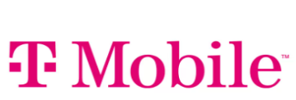
T-Mobile customers that join the Fuel Rewards® program through a custom registration link, will save at least 30¢/gal on their 1st fill. This limited-time offer will run from September 16 – October 21. The 30¢/gal offer includes Gold Status and is limited to 20 gallons in a single transaction. T-Mobile customers that join the Fuel Rewards® program through this offer will not receive 10¢/20¢/30¢ acquisition offer.

Fuel Rewards® In-Store Frequent Shopper Offer Extended
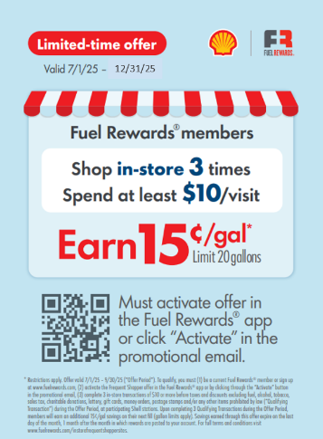
We are excited to announce that the Fuel Rewards® In-Store Frequent Shopper offer is being extended until December 31, 2025. This limited-time offer is fully funded by Shell and designed to drive more in-store purchases by incentivizing and rewarding Fuel Rewards® members. This offer is available at participating sites, which includes locations with product exclusions already set up in the Fuel Rewards® loyalty host, plus sites where Symphony AI was able to categorize transaction data and identify excluded products such as tobacco, lottery, alcohol and more. If you have sites that were not eligible to participate during this offer period, please contact your Territory Manager to see how they may be able to qualify for future offers.

As a reminder, this is how the offer works:

How it works:
- Fuel Rewards® members must activate the offer in the Fuel Rewards® app or via email communication.
- After 3 qualifying in-store purchases of $10 or more, they earn 15¢/gal savings.
- Fuel Rewards® members may earn up to 6 rewards during the promotional period that runs from July 1– December 31.
- This offer is complementary to any existing basket offers a site may be running and can be stacked with other rewards for bigger savings.

Campaign details:
- The offer will appear in the Fuel Rewards® app on the In-Store Rewards tile and station locator
- Fuel Rewards® members with zip codes near participating locations will be notified via push notification and targeted email communication.
- Print-ready POP material is being updated to include the extension and will be posted in MarketHub once it has been finalized. The print-ready POP includes a change mat insert, window sign, counter card, cooler cling, aisle invader and spec sheet to take to your local printer. Click here to view and download the POP.

