Shell Trading & Supply

Carrier Version
Uniform Loading Instructions, Procedures & Terminal Rules

Supplemental Hazard Communication and Emergency Information

This manual was specifically prepared for use for all Shell Trading & Supply Distribution terminals. For any questions or comments pertaining to the content, or to order copies, contact Shell T&S Distribution Operations Support.

Table of Contents
FORWORD 3
ACCESS RIGHTS 3
DRIVER CERTIFICATION 4
IOGP LIFE SAVING RULES 6
PPE MINIMUM REQUIREMENTS 7
GENERAL TERMINAL RULES 8
DELIVERY VEHICLE REQUIREMENTS 9
Vehicle Mode of Power REQUIREMENTS 9
LOADING PROCEDURES 10
DISCONNECT SEQUENCE 10
BILL OF LADING 11
APPENDIX A - EMERGENCY INFORMATION 11
FIRE 11
SPILLS 11
TERMINAL SECURITY 11
EARTHQUAKES 11
TORNADOS 11
LIGHTNING 12
PERSONAL HEALTH AND SAFETY INFORMATION 12
DECONTAMINATION 12
APPENDIX B - GUIDELINES FOR TRUCK LOADING SEQUENCE 13
APPENDIX C - FORMS 14
Carrier Access Agreement 14
Exhibit A - Located in Carrier Access Agreement above 14
Exhibit B - Located in Carrier Access Agreement above 14
Exhibit C – Located in Carrier Access Agreement above 14
DRIVER LOADING RACK CERTIFICATION 14
DRIVER WALK THROUGH CERTIFICATION 14
DRIVER CARD HOLDER AGREEMENT 14
DRIVER COMMUNICATION 15
VEHICLE CARGO TANK DATA SHEET 15
APPENDIX D - US DRIVER SAFETY ORIENTATION - LOG IN PROCESS 15
APPENDIX E – Shell operations specific instructions and forms 15
APPENDIX F - DRIVER VIOLATION PROCEDURE 16
ADMINISTRATION DOCUMENTS 20
Training Log 22

FORWORD
Shell strives to set the highest standards in the industry by providing a safe and socially responsible work environment. The development of this document provides each customer and Shell employee with the minimum requirements that must be adhered to while loading and offloading at Shell facilities.
Safety is a deeply held value at Shell. Goal Zero is our vision for causing no incidents or harm to people.
Goal Zero means:
- No one gets hurt and we cause no harm to the environment
- If we cannot do it safely and without harm to the environment, we will not do it
Shell’s HSE Golden Rules: You & I
- Comply with the law, standards, and procedures
- Intervene in unsafe or non-compliant situations
- Respect our neighbors

HSE golden rules are behaviors that must be applied in every operation and activity we do.
Stop Work Authority and Intervention:
- You have the authority to intervene when you feel your safety or another person’s safety is in jeopardy
- You do not have to be right, and you do not have to ask anyone. You just have to care!
- The initiator is responsible to act in a respectful manner while delivering the intervention
- The receiving person is responsible to act professionally and consider the intervention
This document also outlines the process that will be used to adjust behaviors that are unsafe or illegal in a fair and impartial way.
NOTE: 24hr CCTV in operation at all Shell Terminals. Images are being monitored and recorded for the purposes of safety, security, and process improvement.

ACCESS RIGHTS
In order to load or offload products at Shell US Terminals, a Terminal Access Agreement must be on file before access is granted. Subject to the terms of the Shell Terminal Access Agreement, Shell grants Customer/Carrier access to the Terminals and the right to load or offload products. Shell will provide the Customer/Carrier with the TMS Loading Cards that are required to access Terminals in order to load or offload products.

Customer/Carrier undertakes and agrees to the following:
- Loading Cards are the property of Shell and shall, at the request of Shell for any reason whatsoever, be returned to Shell immediately.
- to use the Loading Cards in accordance with the Terminal Access Agreement.
- to retain the Loading Cards at all times in Customer/Carrier possession or control.
- to not permit anyone, other than the Authorized Driver to whom they were issued, to use them.
- to not duplicate the Loading Cards or permit the Loading Cards to be duplicated; and
- to immediately notify Shell of any theft, misplacement, or loss of any and all Loading Cards.
- Any damage caused by drivers not following procedures will be charged back to the carrier.
  - Examples include pulling down scully cord, running into fences/gates, etc.

The Loading Cards issued to the driver are not transferable and may only be used by the Authorized Driver to whom it was issued. If the Authorized Driver’s access ceases to be authorized by the Customer/Carrier, the Customer/Carrier shall notify Shell immediately by telephone followed by writing (Exhibit B Form - Add/Remove).

Customer/Carrier agrees to pay Shell twenty-five dollars or any other reasonable fee which Shell may charge from time to time for the replacement of each Loading Card which may be lost, stolen, misplaced, broken, damaged, defaced, mutilated or which may otherwise disappear or be rendered unusable.

Customer/Carrier use of Terminals shall be through Authorized Drivers only and entirely at their own risk. Neither Customer/Carrier nor its Authorized Drivers shall permit any person, whether or not under their control or direction, to have access to the Terminals without Shell’s prior written consent.
Prior to loading or unloading a cargo tank/trailer for the first time, the Customer/Carrier needs to provide the Terminal with key safety and regulatory information regarding the equipment to be used. This information is outlined in the Vehicle Requirements section below.

DRIVER CERTIFICATION
Prior to an Authorized Driver arrival at a Terminal to load or unload product, the Customer/Carrier shall ensure the Authorized Driver has a valid Driver’s License for the location and type of vehicle they are driving along with permits and certifications required by law for the safe and legal operation of the vehicle used to transport products.

New Carriers must complete an Exhibit A form with a list of authorized drivers to load or offload products at Shell Terminals on the Carrier’s behalf prior to scheduling the terminal site-specific walk through.
Existing Carriers must complete an addendum to Carrier access agreement Exhibit C form to add or delete drivers from loading or offloading products at Shell Terminals on the Carrier’s behalf. The Exhibit C form must be sent via email or fax to the Terminal authorizing driver(s) requiring a site-specific walk through or deletion from Carrier’s database.
New drivers must successfully complete the Shell global web-based training course using this link: US Driver Safety Orientation. This web-based training can be completed from any computer from any location 24/7 for your convenience. Once the US Driver Safety Orientation has been successfully completed, the driver/carrier must schedule a site-specific walk through along with a Competency Assessment within 90 days. This site-specific walk through will ensure that the new driver is aware of Shell’s Life Saving Rules, loading instructions and emergency procedures. After these steps are successfully completed, the driver will be issued a terminal access card and can begin training with the driver trainer on Shell property. Every person (trainee and trainer) entering the facility must card in at the entry gate. This allows for accountability for all personnel within the facility during an emergency event.
Once the driver trainer is confident in the competency of the new driver to safely load unsupervised, the driver trainer must complete the Shell Loading Rack Certification Form validating that the driver trainee successfully completed three loads with driver trainer’s oversight. The driver trainer and trainee will schedule the final competence verification with the Shell operator. At the scheduled competence verification, the driver trainee will submit the Shell Loading Rack Certification Form to the operator. The operator will witness the driver trainee load or offload the vehicle without any intervention. If competence is proven, the Shell operator will enable loading privileges on the driver trainee’s access card. If a driver is not deemed fully competent, they must go back through the entire three-load process again with the driver trainer.
To maintain loading privileges, authorized drivers are required to go through a driver re-certification process every three years by completing the web-based US Driver Safety Orientation, a site-specific walk through and a Competency Assessment within 90 days of completion. The driver must print the certificate as evidence of completion and provide the certificate to a Shell operator to update the driver’s training record in TMS during the scheduled walk through.
Compliance with all procedures is required to maintain loading and offloading privileges at Shell Terminals. Repeat violations by the same driver can result in a driver losing their loading card privileges and repeat findings by a carrier resulting from illegal or improperly maintained equipment may result in loss of loading/unloading privileges. To ensure a fair and consistent process, Shell Management will be involved in all disciplinary action. Exception: A high RAM rating violation over the weekend/holiday may include suspending a driver’s access and loading privileges until review by Shell Management can be scheduled.

NOTE: The process for authorizing inactive drivers that have been automatically locked out by the TMS system for inactivity will depend on the length of time the driver has not loaded at a Shell terminal will dictate the level of training/recertification required.
- >90Days; <180 – Operator verifies that nothing at the facility has changed in the period that the driver was inactive. Operator has a conversation with the driver to ensure he/she can identify the critical safety systems (ESD), evacuation (muster/routes) and loading rules (staging, spotting, backing, etc.)
- =/>180 days; < 365 – Operator issues the driver a “Terminal Specifics” packet and then performs a terminal Specific “Walk Through and competency assessment” with the driver. Driver must schedule with operator to witness competency for the first load.
- =/>365 days – If the driver has not loaded at any Shell facility, the driver is treated as a new driver and must be recertified and re-carded following the procedure in the first section (Procedure – New Driver “Issuing a Loading Card”)

IOGP LIFE SAVING RULES
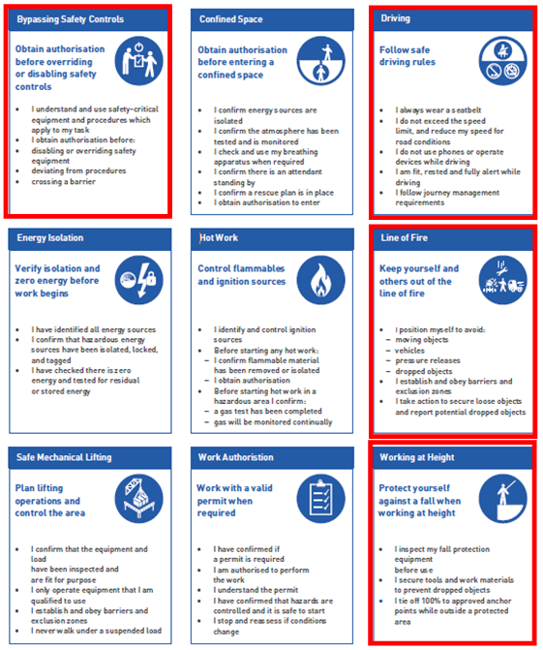
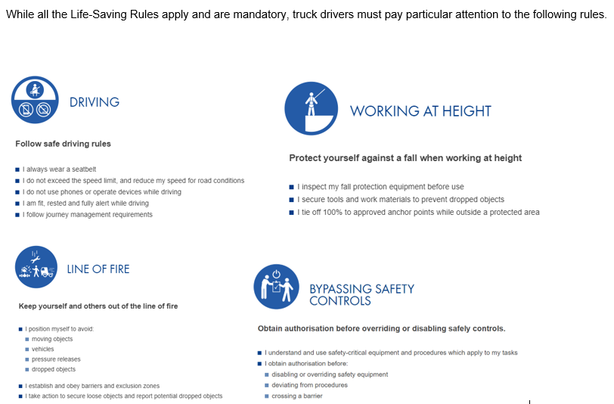

PPE MINIMUM REQUIREMENTS
- Head Protection: Head protection is a hard hat that meets Class G or E requirements as specified by ANSI Z89.1. Class E is preferred for those involved with electrical work. Metal hard hats are prohibited because they do not provide protection from electric shock. Liners for protection from cold may be worn under hard hats. Liners must be specifically designed for this use. Chinstraps are required when working at heights greater than six feet (1.8 meters).
- Protective Clothing: All people at a facility under Shell T&S AM operational control must wear hi-visibility non-static producing fire-retardant clothing outside of an office environment, vehicle, or employee parking area. Hi-visibility clothing, safety vests or striped reflective coveralls/uniforms are acceptable). Stripes can be attached to non-fluorescent clothing (blue for example). Note: All FRC garments must be NFPA 2112 certified. In cold weather/rain environments, it is important to ensure that any outer garments (i.e., Jackets, coats) worn over primary FRC must also meet appropriate protection factors for the application in which the FRC is being used. FRC clothing should be the outer layer clothing if layered clothing is being worn. Acceptable rainwear meeting or equivalent ASTM F2733.
- Eye Protection: Minimum eye protection consists of safety glasses with side-shields that meet ANSI Z87.1. or splash goggles/face shield are required.
- Foot Protection: ASTM F2413 Approved safety-toe (steel), puncture resistant, slip resistant soles, chemical resistant boots.
  - Safety shoes must be made of
    - leather or leather-type material that covers the entire foot,
    - non-absorptive materials, and
    - have a non-slip oil / chemical resistant sole
    - puncture resistant soles
- Gloves - Chemical/oil resistant (example nitrile rubber)
- Long trousers, no shorts

GENERAL TERMINAL RULES
Smoking is only acceptable in designated areas.
No person shall use, possess, transport, promote or sell drugs, alcoholic beverages, firearms, weapons, or dangerous materials while on Shell property.
Speed limit in the terminal is 5 MPH, unless otherwise posted.
All vehicles parked or left unattended must have the engine turned off and the parking brake set. Truck idling is prohibited.
All lights, radios, cell phones (including Bluetooth) and electronic devices are to be turned off and left in the vehicle while on the loading rack.
The use of smart watches such as the “Apple Watch” are prohibited in hazardous classified areas and must be left in the vehicle while loading or unloading.
Each driver must only use the Shell access card issued to them during the rack certification process. This card is the driver’s responsibility along with the pin access code that is not to be shared.
Carriers are responsible for ensuring that the drivers and vehicles meet Shell and DOT requirements.
A driver must not operate any equipment, which is not in proper operating condition and must report any equipment defects or malfunctions to terminal personnel.
Product releases will not be accepted as a normal occurrence. If any product is released, it must be reported to terminal personnel.
Mechanical work or use of jumper cables is not allowed in the immediate area of the loading rack. The vehicle must be towed to a safe location away from the load rack area before making repairs. Permission must be obtained from terminal personnel before this type of activities can occur.
The use of plastic buckets or any other bucket not equipped with a proper bonding device is strictly prohibited at any Shell facility.
Do not remove your product or vapor dust covers until positioned on load rack.
No flipping of placards while on the load rack.
Vehicle doors and windows must be closed while loading.
Driver trainers must remain with their trainee throughout the entire loading process.
A spotter is required if vehicles must back up.
If you need to leave the load rack for any reason other than an emergency, disconnect all equipment from your vehicle before you leave the load rack.
Trailers must be completely empty before arriving at the terminal. Draining of compartments on Shell property is prohibited.
Loading on top of retain is prohibited. Only under special circumstances following the MOC process or approved written Procedure (LOP) that ensures risks have been mitigated to maintain safe loading operation and approved by Shell Terminal Managers and Facility Manager.
Drivers must always enter and exit cab maintaining three-point contact.
Consumption of food or beverages while loading or off-loading products is prohibited.

DELIVERY VEHICLE REQUIREMENTS
All units must meet the following requirements:
- Meet the required DOT regulations
- If Alternative fueled vehicle other than Diesel fuel, meet required ANSI/NFPA standard (see Vehicle Mode of Power Requirements)
- Have a functioning brake interlock system to prevent truck movement while the loading adapter is connected
- Vehicle identification numbers clearly displayed on each vehicle
- Safe fill capacity clearly indicated for every compartment in US gallons
- Overfill prevention system that meets the following requirements and provides documentation thereof:
- The overfill probes are positioned to leave free space in each compartment (minimum 60 gallons) below the bottom of the probe.
- The system, including each probe, has been annually wet tested; and documented
- Cargo tanks outfitted with “Crossover” valves <<shall>> be verified closed by driver, before entering shell property. It is carriers’ responsibility to ensure that these valves will never be used on Shell Property. Failure of a crossover valve or use of such valve is a serious violation that may affect the drivers loading privileges.
- VKIP certifications dates posted on the tanks and testing documents supporting VKIP dates available on the unit.
- Current vapor certification, State markings on tanks and supporting documents available on the unit
- API male coupler, wear test, out of roundness test and collar thickness test must be documented
- Externally mounted cameras and other electrical equipment. Cameras or any other electrical equipment must meet area classification requirements (Class 1 Div. 2) or powered through ignition switch and when switch is turned off power is removed for cameras or other electrical equipment.
- Submit the Vehicle Cargo Tank Data Sheet annually along with the vapor certificates to prevent lapse in loading privilege.

All vehicles are subject to random vehicle inspections. Any out of compliance of the items above will subject the vehicle to immediate lock out until vehicle has been repaired with proof of repair supplied to the terminal along with re-inspection.

Vehicle Mode of Power REQUIREMENTS
- Alternative Fuel Powered Vehicles must be clearly labelled to enable easy identification for terminal staff and Emergency Responders. (LNG/CNG/H2/EV)
- CNG/LNG/H2 powered vehicle requirements
  - Liquid Natural Gas (LNG), Compressed Natural Gas (CNG), and Hydrogen (H2) fueled vehicles will require documented evidence to verify that the vehicle has been constructed and certified in accordance with one of the following specifications or a standard that meets the equivalence of the following standards: UNECE R110 or ANSI/NFPA 52 or CSA B109-17 or AS/NZ 2739/2009.
  - For Hydrogen (H2) and Hydrogen Fuel Cell Vehicles (HFCV): UNECE R134, UN GTR13, ISO 23273 (for gaseous H2), ISO13985 (for Liquid H2), SAE J2578, SAE J2579, ISO/TR 15916, The (EC) No 79/2009 EU H2 Regulation in Europe.
  - Vehicles will not be granted access where the engine has been converted from a combustion engine into a spark ignition engine or where the original spark ignition engine does not have encapsulated spark ignition (Coil on Plug COP).
- BEV/HFCV Powered vehicle requirements
  - BEV: UNECE R100, UN GTR 20, GB 18384-2020, GB 38031-2020, NFPA855, ECE/TRANS/180/Add.20
  - ++Loading/unloading of tanks connected to a BEV/HFCV shall not be allowed unless the cargo is a product with a flashpoint higher than 60C/140F or Diesel fuel with a flashpoint complying with EN 590.
    - ++Potentially in 2025 the technology for battery safety will be developed allowing all products to be loaded/unloaded regardless of flashpoint.
- Drivers <<shall>> not enter a Shell Facility if:
  - LNG Fuel tank pressure gauge reads > 13bar/ 190PSI
  - CNG/H2 Fuel tank pressure gauge reads > 300bar/4300PSI or
  - CNG Fuel Tank Temperature gauge is > 75 degrees Celsius / 165 Fahrenheit
  - CNG/H2 fuel tank has exceeded its inspection or expiration date as required by ISO 11439.
  - **EV powered vehicles with an active Battery Runaway alarm
    - Not allowed to charge an EV powered vehicles in a classified area or in area that is not well-ventilated.
  - Additionally, for LNG
    - Parking for periods exceeding 72 hours continuously is forbidden
**Note: EV Powered Vehicles (BEV-Battery Electric Vehicles and HFCV-Hydrogen Fuel Cell Vehicle)

LOADING PROCEDURES
- Stage vehicle at stop line
- Turn off all non-essential vehicle equipment that can be turned off, including but not limited to cell phones, smart watches & Bluetooth devices, set brakes and shut off engine (no idling)
- Only one carded driver allowed on each lane, except for training new drivers
- When lane is available pull-on rack and spot truck, set brakes and shut off engine
- You must wear required PPE
- Place safety cone at front or rear (terminal specific) of vehicle
- Validate the truck is empty by visually inspecting retain indicator if equipped and tapping on the tank
- Connect scully plugs (verify appropriate lights on scully box)
- Insert loading card (check allocations)
- Connect vapor hose
- Connect loading arm, open internal valves only on compartment(s) being loaded
- Follow directions on load controller
- Enter preset gallons to be loaded (validate within safe fill)
- Verify product, gallons and compartment entered on preset being loaded match the load arm and compartment to be loaded
- Press the enter button on preset to begin loading
- Verify that there are no leaks or drips coming from Shell’s equipment or transport
- Stay in front of load controller to monitor presets until loading is complete, continuing to monitor connections for leaks (safety watch)
- Observe slow flow shutdown of all meters. If slow flow does not engage, stop the flow immediately by pressing the stop button on pre-set. Report malfunction to terminal operator
- No eating, drinking, talking to other drivers or filling out paperwork while on load rack. Full attention must be given to load controller
NOTE: Any stoppage of flow due to product contacting the optical sensor in the compartment being loaded must be reported to operations immediately. Draining product or gravity flowing product between compartments to resume loading is not allowed on Shell property. Manipulation of the overfill protection system that bypasses critical safety equipment is a serious violation (IOGP Life Safety Rule – Bypassing Safety Controls) that will be addressed accordingly.

DISCONNECT SEQUENCE
- Pull loading Card
- Close internal valve after loading each compartment
- Disconnect loading arm
- Disconnect vapor hose
- Disconnect scully plugs
- Verify that all loading equipment has been disconnected from the vehicle and stowed appropriately
- Ensure all caps and covers are in place and vehicle is liquid tight
- Gather safety cone from front or back of vehicle and re-verify that all loading equipment has been disconnected from the vehicle
- Place safety cone back in its designated spot
- Buckle up your seat belt, check your mirrors, pull off the loading rack to parking area, set parking brakes, and shut off engine
- Review BOL and check for accuracy, sign and leave a signed copy

BILL OF LADING
All copies left at terminal must have driver signature.
Never leave the terminal without a BOL. It is a DOT violation to leave the terminal without an accurate and signed BOL. Contact terminal operator or the LSS Help Desk (+1-800-345-6666) if you do not receive a BOL.
If the printer is out of paper, follow provided instructions on the BOL printer to switch to the next printer.

APPENDIX A - EMERGENCY INFORMATION
The following emergency information is included only as a guide in the absence of more specific requirements from the specific terminal.

FIRE
- Remain calm and do not attempt to remove your truck from the load rack
- Activate Emergency Shut Down and evacuate to muster point
- Call 911 and notify terminal personnel

SPILLS
- Immediately stop flow on product meters
- Do not move vehicle or allow other vehicles to enter the loading rack
- Contact terminal personnel for evaluation and assistance
- Report to muster point for further instructions, if warranted

TERMINAL SECURITY
The terminal gates can only be activated with an authorized terminal access card. Each person entering the facility must card in with his or her own authorized terminal access card for emergency evacuation control. Any person that does not have an authorized access card must report to the office and sign in on visitor’s log. Note: Prior to exiting the terminal the signed in visitor must sign out.
Do not allow other vehicles to enter the facility behind your vehicle (no piggy backing)
Report any unauthorized access or suspicious activities to the on-duty operator or on call operator and contact local authorities (911)

EARTHQUAKES
If an earthquake occurs, stop all loading, safely secure loading equipment, move to safe area and notify terminal personnel. Do not resume loading until directed to do so by terminal personnel.

TORNADOS
One of the worst places to be during a tornado is in a vehicle. Park your vehicle and seek a sturdy building or ditch. Stay low to the ground or below the ground in an interior space away from windows. Cover your head with your hands and arms.

LIGHTNING
If thunder and lightning occur, stop all loading at the first sign and do not resume loading unless directed to do so by terminal personnel.

PERSONAL HEALTH AND SAFETY INFORMATION
Safety Data Sheets (SDS) are available at all facilities and the location of these SDS sheets is identified in the terminal specific addendum.

DECONTAMINATION
Avoiding contact with hydrocarbon is the best protection. If you are splashed with product of any kind, quickly flush with cool water while removing contaminated clothing and shower with soap / cool water. Product-soaked cloths are flammable even if they appear dry. Do not leave product-soaked cloths indoors. Do not reuse contaminated clothing or shoes until they have been cleaned. It is recommended that you have a change of clothing available.

APPENDIX B - GUIDELINES FOR TRUCK LOADING SEQUENCE
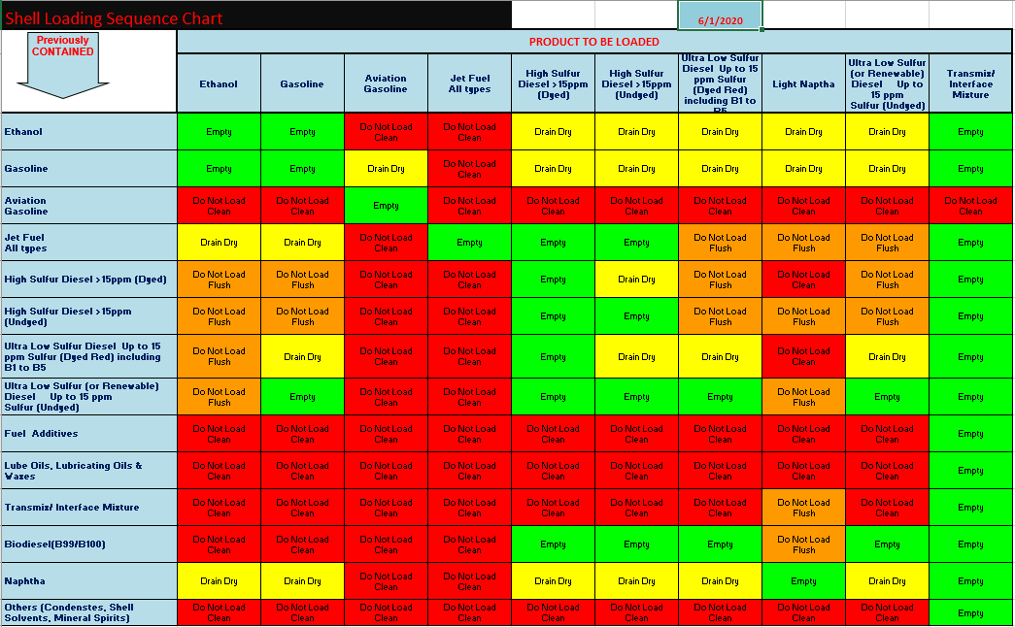
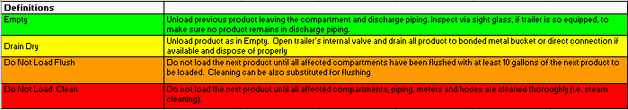

APPENDIX C - FORMS

Carrier Access Agreement
This set of documents includes the Carrier Access Agreement, Appendix 1 – Alternative Fueled vehicle requirements/standards, Appendix 2 - Road Transport Vehicle Utilizing Externally Mounted Cameras and other non-essential electronic devices. Exhibit A – Listing of Authorized Representatives / Cardholders, Exhibit B – Carrier Information, and Standard Carrier Code Application Form. Send completed forms to the group mailbox SOPUS-TDM@shell.com

Exhibit A - Located in Carrier Access Agreement above
To be used for setting up a new carrier listing of all authorized drivers.

Exhibit B - Located in Carrier Access Agreement above
Used to gather contact, Tax Id and SCAC code details for the Carriers.

Exhibit C – Located in Carrier Access Agreement above
Used to add /delete drivers from an existing authorized carrier. To add new drivers to a carrier, this form is to be completed after the driver receives the online certificate indicating a passing grade of the US Driver Safety Orientation Training.

DRIVER LOADING RACK CERTIFICATION
This form is to be completed by the driver trainer, once driver trainer certifies the trainee as being competent then the 4th load will be reviewed by Shell Personnel validating competency.

DRIVER WALK THROUGH CERTIFICATION
Upon completion of the driver site specific walk thru and competency assessment the driver will acknowledge receipt and understanding.

DRIVER CARD HOLDER AGREEMENT
Driver agrees to abide by all Federal, State, and local laws, ordinances, and regulations, Shell Life Saving Rules

DRIVER COMMUNICATION
Driver communication form will be issued for any violation beyond intervention/coaching

VEHICLE CARGO TANK DATA SHEET
This sheet must be completed annually and returned to the issuing terminal.

APPENDIX D - US DRIVER SAFETY ORIENTATION - LOG IN PROCESS

APPENDIX E – Shell operations specific instructions and forms
LOP-PHV7-009-DRIVER COMPETENCY AND CARDING DRIVER IN TMS.docx
LOP-PHV7-014-Certifying Prime Movers.docx
LOP-PHV7-015-TANK TRUCK HM183 INSPECTION_CERTIFYING CARGO TANKS.docx
FORM - Driver Competency Assessment.doc
FORM - Driver Certification Checklists.xlsx

END OF DOCUMENT

ADMINISTRATION DOCUMENTS
SOP Revision Record
Approval Record
 | Name/Title | Date | Signature or email Signature
Prepared By: | John Domagala Manager Distribution Operations Support West | 06/21/2023 | J.M. DOMAGALA
Owner: | John Domagala Manager Distribution Operations Support West | 06/21/2023 | J.M. DOMAGALA
Reviewer/Approver: | Jason Pace Manager Distribution Operations Support East | 06/21/2023 | Jason Pace
Reviewer/Approver:
Reviewer/Approver:

SOP Revision Record
Date | Page # | Description | Name
02/27/2018 | 6 of 17 | PPE Update FRC | JMD
04/19/2018 | 6 of 20 | PPE Update FRC | JMD
07/24/2019 | 14, 16 of 18 | Circumventing low flow start volume/rate (V.6) | JMD
09/10/2019 | 6, 14 & 16 of 19 | PPE Requirement, added Note – tucked in shirt tail. Added flood loading(V.6) | JMD
02/14/2020 | 12 | Truck loading sequence updated | MT
04/28/2020 | All | Driver certification, forms, Delivery vehicle requirements, guidelines for truck loading sequence | MT
06/01/2020 | 10, 12 | Loading sequence chart, US driver orientation web link and log in process | MT/JMD
04/19/2021 | 7, 12 | Version 8; Externally mounted camera requirement and updated Form – Vehicle Cargo Tank Data Sheet | MT/JMD
09/23/2021 | 7, 8 | Version 9; addition of LNG/CNG powered vehicle requirements. Replaced Carrier access agreement, updated Form – Vehicle Cargo Tank Data Sheet, removed individual Exhibit A, B all-inclusive in Carrier Access Agreement. Life Saving Rules updated to IOGP LSR. | JMD
01/18/2022 | 13 | Version 10 - Carrier Access Agreement group mailbox address to sign up new carrier. | JMD
05/19/2023 | 6,7,9,10. | Version 11 – Pg6/7 IOGP Life Saving Rule updated, Pg9 Vehicle mode of power requirements added EV and H2; Pg10 disconnect sequence moved pull card to 1st from 5th. page 17 to include open crossover valves. | JMD
06/29/2023 | 14, 15, 17 | Version 12; PG14 Replaced carrier Access Agreement with the latest version 2.0. Updated Page 9-Delivery vehicle requirements and the “driver Violation Procedure” page 17 to include open crossover valves.; Appendix D, Driver orientation login process update. Appendix E Shell operations specific instruction and forms | JMD
12/22/2023 | 15 | Version 13; Vehicle Cargo Tank Data form has been updated to include identifying a dedicated bonding/grounding point on the cargo tank vehicles to ensure an adequate bond is achieved with a resistance of <10 ohms. | JMD
03/12/2024 | 4 | Version 14; Corrected error on page 4 “Driver certifications” changed from Exhibit B to Exhibit C, | JMD

Training Log

Operator/Contractor Sign Off - I have been trained on this process and have reviewed and understand this SOP
Name/Title | Company | Date | Signature

